# Disaster Detection System



**by**

**Ali Hassan (F14-1421)**

**Muhammad Shahroz Abbas (F14-1266)**

**Muhammad Bilal Akhtar (F14-1346)**

**Supervised by**

**Miss Maria Bashir**

A Final Year Project (FYP) Documentation Submitted to the

Department of Computer Science

In partial fulfillment of the requirements for the degree of

Bachelor of Sciences in Computer Science/Information Technology/ Software Engineering

**Lahore Leads University**

**Lahore**

**March 2018**

# Receiving Form

**Supervisor Name: ______Maria Bashir______**

**Signature:________________________**

**Date:________________________**

# 

# ACKNOWLEDGEMENT

First of all we would like to say thanks to the Almighty Allah for blessing us good health and making straight paths for us during the development of the whole project. We would like to mention our parents and dedicate our gratitude towards them because without their condescension we are nothing.

We also want to mention our supervisor **Miss Maria Bashir** for her huge guidance throughout the span of this project and the outclass teaching in our previous courses.

To all my friends for their unbiased support, shoulder to shoulder assistance during the whole course and the courage due which we are now on this stage.

# ABSTRACT

Over the past few decades world has undergone rapid progress in the fields of science and technology. Since the progress did not just made the modern world reliable for the humans but also there can be seen lots of major issues in various fields of life. A very vital role of the vehicles moving on the roads is not just a good gesture but unfortunately lots of issues born from it. Many people die in a day just because of the road accidents. At the state levels serious actions are taken to avoid the crashes but people die also because after the accident no help reach to rescue them in time. Sometimes the accidents occur in very low populated areas where no one can identify the victims due to which lot of damage is observed. So we planned to make a Disaster detection system due to which we will be able to get the notification of the accident as well as the pin point location of the spot.

The basic purpose of our system is to save humans before they expire. Since there are lots of occasions where we have no nearby any symbol of residential population who might able to respond us very fast and give us medical assistance before severe lose. In that situation of emergency our system will fulfill the gap of response and alert requirement. In sample words the persons who have our system will no need to worry about the conditions occurred after the accidents that who will respond them and rescue them. We have developed a very simple and user friendly system for the long lasting survival of the humans.

We have made a simple system having two major parts one is hardware part and second is software part. The hardware part is consisted of the accelerometer for the purpose of X and Y coordinates of the vehicle, vibration sensor for the jerking and sudden collision identification and control unit of our system that is Arduino. While in software side we will be using an Android application coded in visual studio through C# using Xamrine Platform.

Table of Contents

***Title***

Disaster Detection System 1

Receiving Form 2

ACKNOWLEDGEMENT 3

ABSTRACT 4

Table of Figures 8

List of Tables 10

Chapter 1 11

1.1 Problem Statement 13

1.2 Objective Project 13

Chapter 2 14

2.1 Existing systems 14

2.1.1 Intelligent Accident-Detection and Ambulance-Rescue System 14

2.1.2 SOSMart App 16

2.1.3 Accident Detection using Android Smart Phone 17

2.1.4 Smart Accident Notification and Collision Avoidance System 18

2.1.5 Real Time Vehicle Accident Detection and Tracking Using GPS and GSM 19

2.2 The Proposed Disaster Detection System 20

2.3 How our idea is different? 21

2.3.1 Dynamic user friendly 21

2.3.2 Smart phone’s GPS and GSM technology 21

2.3.3 NO Application in Pakistan 21

Chapter 3 22

3.1 Hardware 22

3.1.1 PC 22

3.1.2 Printed Circuit Board (PCB) 22

3.1.2.1 Types of PCBs 24

I. Single Sided PCBs 24

II. Double Sided PCBs 25

III. Multilayer PCBs 26

IV. Rigid PCBs 27

V. Flex PCBs 27

VI. Rigid Flex PCBs 28

3.1.3 16x2 LCD 29

3.1.4 Arduino UNO REV 3 29

3.1.4.1 Why we use Arduino? 30

3.1.5 Bluetooth Module HC-06 31

3.1.6 Accelerometer MPU 6050 32

3.1.7 Vibration Sensor 33

3.1.8 Battery 33

3.1.9 Regulator LM7805C 34

3.1.10 Capacitors 34

3.1.11 Resistors 35

3.1.12 Switch and LED Bulb 35

3.1.13 Android Smart phone and data Cable 35

35

3.1.14 Car Model 36

3.1.15 Soldering tools 37

3.2 Software 38

3.2.1 Microsoft Visual Studio 38

3.2.2 Arduino Software 38

Chapter 4 39

4.1 Hardware development process 39

4.1.1 Block Diagram 39

4.1.2 Printed Circuit Board (PCB) block diagram 41

4.1.3 Configuration of LCD with Arduino 42

4.1.4 Power supply distribution 43

4.1.5 Bluetooth module working 44

4.1.6 Setting up Vibration sensor 44

4.1.7 Accelerometer configuration 45

4.1.8 Assembled Hardware Unit 46

4.2 Software Development Process 47

4.2.1 Main Activity 47

4.2.2 StartPage Activity 48

4.2.3 Main Activity 49

4.2.4 Working of Code from start to end 50

4.2.5 Manifest Permissions 50

a) Bluetooth 50

b) SEND _SMS 50

c) Read _Phone_State 51

d) Access_Course_Location 51

e) Access_Fine_Location 51

f) Internet 51

4.2.6 Dumping the code into Arduino 52

A. Code for Arduino 52

Chapter 5 56

5.1 Test Case 56

5.1.1 Pairing the Bluetooth module with smart phone 56

5.1.2 Startup the Application and connected the HC-06 57

5.1.3 Entered the Required Data 58

5.2 Result 59

Chapter 6 60

6.1 Conclusion 60

6.2 Future Direction 61

6.2.1 Panic Button 61

6.2.1 Link with Local Emergency services 61

6.2.2 Entering of Multiple Alerted Contacts 61

6.2.3 Mobile Application for IOS Users 62

Chapter 7 63

7.1 Distribution of work 63

7.2 Gantt Chart 65

References: 66

Plagiarism Report 67

***Plagiarism Report 68***

# Table of Figures

**Figure 1 IA-DARS Hardware Part Figure 2 IA-DARS Software Part 15**

**Figure 3 SosMart Front end 16**

**Figure 4 AD – using - ASP 17**

**Figure 5 SANCAS Block diagram 19**

**Figure 6 Real time Block diagram 20**

**Figure 7 Printed circuit board 23**

**Figure 8 Single Sided PCB 25**

**Figure 9 Double Sided PCB 26**

**Figure 10 Multilayer PCB 26**

**Figure 11 Rigid PCB 27**

**Figure 12 Flex PCB 28**

**Figure 13 Rigid Flex PCB 28**

**Figure 14 LCD 16×2 29**

**Figure 15 Arduino UNO Rev 3 30**

**Figure 16 Bluetooth Module HC-06 31**

**Figure 17 Accelerometer MPU 6050 32**

**Figure 18 Vibration Sensor 33**

**Figure 19 Battery 4V 33**

**Figure 20 Regulator LM 7805C 34**

**Figure 21 Android mobile & data cable 35**

**Figure 22 Car Model 36**

**Figure 23 Soldering Tools 37**

**Figure 24 Block Diagram of DDS 40**

**Figure 25 PCB Diagram 41**

**Figure 26 Configuration of LCD with Arduino 42**

**Figure 27 Final hardware unit 46**

**Figure 28Start page code & design view 48**

**Figure 29 Main front end code and GUI 49**

**Figure 30 Manifest Permissions 52**

**Figure 31 Pairing the mobile with HC-06 57**

**Figure 32 Bluetooth Page 57**

**Figure 33 Application Loading 57**

**Figure 34 Main Page 58**

**Figure 35 Alert SMS 59**

**Figure 36 Google Map location of the spot 59**

# 

# 

# List of Tables

**Table 1 PBS Annual Accidents Report…………………………………………………………………………………………….13**

**Table 2 Work Distribution……………………………………………………………………………………..………………………65**

**Table 2 Gantt chart………………………………………………….………………………………………….………………………..66**

# Chapter 1

Introduction

In this age of science and technology where we have lots of progress in human life there we also have lots of failures in this modern era. Scientist always tried their best to facilitate humans with several strategies and methodologies. As far as there is concern of the human health issues we have made lots of ways to accommodate the humanity. From emergency actions to the long time patient care we must have to deal with quick response actions to avoid lots of damages taking place in human life.

In a shocking report on Pakistan morality rate has revealed that more number of people die in road accidents than due to any other reason. Unfortunately the number is increasing day by day. The main cause of deaths in Pakistan is not due to road accidents but main reason is no rescue after accidents. Because most of the time people die due to having no quick response and first aid after they got an emergency.

In Pakistan, the Pakistan Bureau of Statistics (PBS) has revealed in his annual report on road accidents that in all the accidents occurred in year 2015-2016, 48% people had died. ("Traffic Accidents (Annual 2015-2016)", 2017).According to a TV report Pakistan is the ranked 1st in road accidents in South Asia while 48th in World. Deadly accidents are major issues in Pakistan due to which every day a lot number of humans die. It means almost half of the people involved in road accidents had died due to not quick response by the rescue teams and emergency squads.

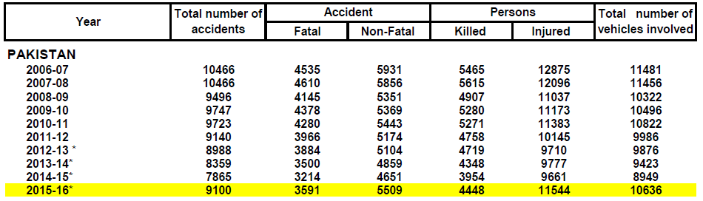

Table 1 PBS Annual Accidents Report [1]

In recent years there has been lots of working in human facilitation along with the emergency control and quick response units who might be able to reach at the spot of disaster and then give them possible first aid. As having view of human life we have made a Disaster detection system which is savoir of life. In our project we introduced a system which will automatic detect an accident and will quickly response to the concern person whom we want to tell that your loved one got an emergency.

The basic purpose of our system is to save humans before they expire. Since there are lots of occasions where we have no nearby any symbol of residential population who might able to respond us very fast and give us medical assistance before severe lose. In that situation of emergency our system will fulfill the gap of response and alert requirement.

This entire project covers the whole system completely accident, detect and avoid the necessity After stepping up Implementing this useful system in every automobiles Up to 90% of mortality rates can be reduced .This is also the purpose as well as mystical driving challenge. We have two main parts of our system consisting of Software and Hardware modules. In software part we will use an Android application installed on person’s mobile that is driving the vehicle whereas the hardware part will be deployed in our vehicle.

# 1.1 Problem Statement

Disaster Detection System will be a savior for the injured people after having a disaster/accident. The idea came from the very own occasions when lots of loved ones were died in a major accident due to not having quick response from the emergency squad and initial assistance. So our project will be a like an angel who reach you in a few moments after someone got an accident anywhere in world.

# 1.2 Objective Project

Our whole concern in the development of project is to facilitate the humans through our proposed techniques for the long survival of humans. Surely we will be able to get following objectives in the end of deployment of our system.

* Disaster detection system is very human friendly.
* It has almost reasonable cost for the safety and life of our loved ones.
* Easy to install Smartphone application and simple to use it.
* Disaster detection system will precisely identify the moment of crash or accident within a millisecond.
* Your loved ones will be notified through Short Message Service (SMS) as soon as collision occurred wasting no time.
* Not only you will be able to get just notification but the precise pin point location of accident spot will be in your hands of concerned person.
* After the deployment of this project in almost all the vehicles moving on roads we will be able to reduce the death ratio in accidents till very low which could be a great success for the human lives.

# Chapter 2

Literature Review

There are lots of thoughts and ideas behind every application and project which cause new hope for better and comfortable world. Currently there are few technologies for accidents detection. As is done manually, there is loss of life in golden hours. The victim of the accident depends on the mercy of others to rush to the hospital. Many times one accident goes unnoticed for hours before help arrives. Due to all these factors, there is a high mortality rate of the victims of the accident. Few existing systems to avoid the road accidents include the electronic anti-lock braking system, distribution of braking force, supplementary restraint system airbags, immobilizer, parking sensors and cruise control.

# 2.1 Existing systems

In any field of science and technology there is lots of working that already has been implemented or on which working is been done. Since we are dealing with embedded systems so we have researched that there are few existing technologies have been introduced by different people from different places of the world. We are not going to discuss them all in details because we have to deal with our proposed system in detail. Few of such systems will be discussed in brief detail along with their short failures and working methodologies.

## 2.1.1 Intelligent Accident-Detection and Ambulance-Rescue System

In this proposed system there is an automatic detection of accident. A sensor, GPS, GSM unit fitted in the vehicle detects the accident and sends the accident location to a main server unit which houses the database of all the nearby hospitals. Ambulance is rushed to the accident spot which carries the patient to the hospital and simultaneously monitors the vital parameters like temperature and pulse rate and conveys them to the concerned hospital. Along with this, there would be control of traffic light signals in the path of the ambulance via RF communication to provide a clear path for ambulance. This will minimize the time required by the ambulance to reach the hospital. [2]

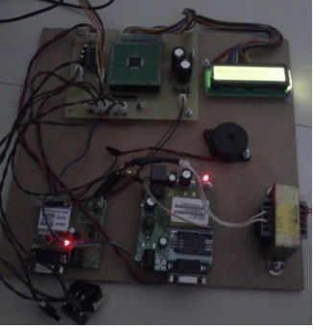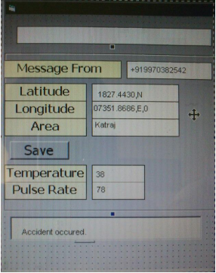

Figure 1 IA-DARS Hardware Part Figure 2 IA-DARS Software Part

**How does it work?**

In the above mentioned system there are main four units which cause whole project smoothly. First of all there is vehicle unit which is mainly proposed of hardware technology. Then the ambulance unit comes which actually is a kind of first aid to the patient having necessary and quick responsive equipment. Now the turn is to clear the way of rescue teams through the traffic junction unit which handles the signals and flow of traffic to go nearby hospitals. Finally the brain of the whole system comes in working which handle all the narrated units as from detection of any accident to the rescue of the patient.

**Drawbacks**

* It a costly project because we need to buy the GPS and GSM units for whole progress.
* Since in some countries like Pakistan, for security issues, GPS and GSM are banned due to which we cannot use these modules independently.

## 2.1.2 SOSMart App

SOSmart detects accidents automatically through using the internal sensors and accelerometer of the Smartphone which will send alert notification with your location to your pre-selected contact so may they can send rescue services as soon as possible. Now the question is that how actually they will know the detection of an accident through just Smartphone.

Actually the app will use professional and sophisticated algorithms designed for real car crash data from the National Highway Traffic Safety Administration. Using the algorithms it will be easy to differentiate the sensitivity of accident whether it is hard, normal and just minor to avoid false alarm.

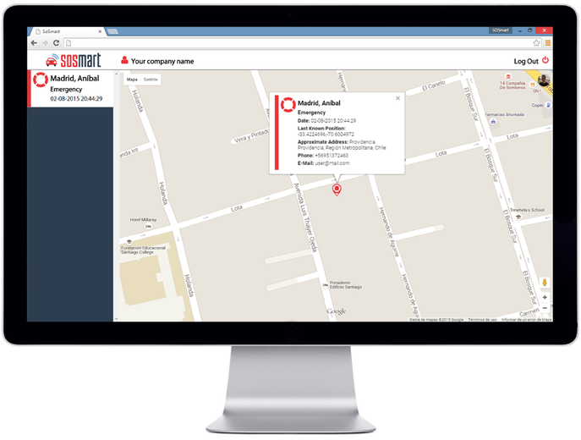

Figure 3 SosMart Front end

**How does it detect car accident?**

During a severe car crash every single thing inside the car are subject to high changes of speed suffering massive accelerations that could reach up to 200 times the gravity. Nowadays Smart phones count with a sensors that can measure accelerations, the accelerometer. This is the same sensor that is used to rotate your screen. Using this sensor output and our professional detection algorithm we can detect if the user has been in a car accident. [3]

## 2.1.3 Accident Detection using Android Smart Phone

The proposed methodology is a system used to give solution for automatically identifying accident alert with the location of spot. Heart beat sensor based integrated system is used with smart phone. Since there is a defined stranded of a normal human heart beat rate (60 to 100 beats per minute BPM). If there is any variation in heart beat rate relevant to given range the system will check it is an accident or not. [4]

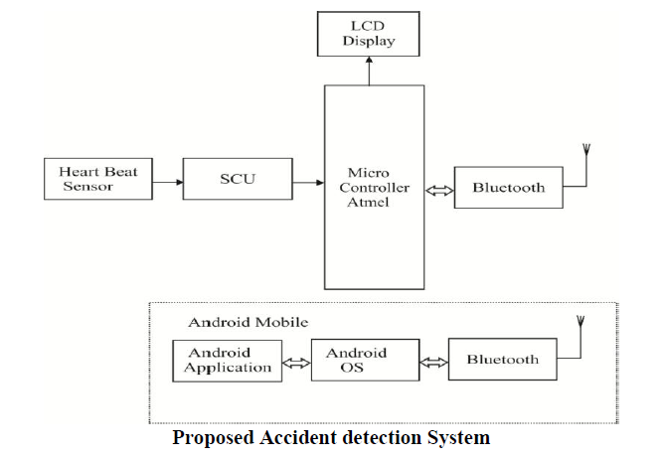

Figure 4 AD – using - ASP

Then the system will send an alert SMS to the pre-selected contact along with the location of the spot. As illustrated in figure 4.

## 2.1.4 Smart Accident Notification and Collision Avoidance System

In this developed system almost the working of system is same like we have also seen in an earlier system. The morality rate of human lives is tried to decrease through this system that is a good step towards human living. In this system there are major four units working simultaneously for the detection of the accidents and alert the loved ones.

First of all there is main front unit called vehicle unit. It includes the sensors, ZIGBEE and microcontroller along with GPS to sense the collisions. In this unit the main work is to send the location of the spot of the accident towards the ZIGBEE which will give further instructions. Actually the GPS will send the latitude and longitude to the main server that means accident had happened here so kindly note down the location and take some serious actions. Secondly the main brain of the system takes position which is called control unit. Definitely the control unit will keep all the record about the nearby hospitals in his database for the patients of the accidents. It will be notified about the accidents and locations through GPS and ZIGBEE

Now when we have got notification and the location of the spot where collision had occurred, the next move must be to rescue the injured persons through sending the ambulance, that’s why it is called ambulance unit. [5] For the better results it is understood that if there are enough modules in ambulance then we will be having more rate for the survival of the patent. In this regard LM35 temperature sensor is used for getting the temperature of the patient and for the pulse rate of the patient IR based obstacle sensor is used in the ambulance unit as can be seen in the figure 5.

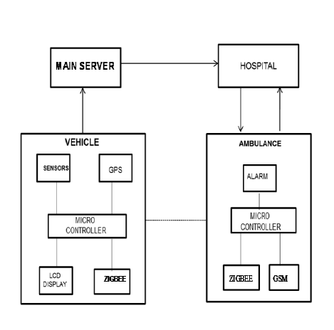

Figure 5 SANCAS Block diagram

## 2.1.5 Real Time Vehicle Accident Detection and Tracking Using GPS and GSM

As we have discussed earlier such similar systems for the detection and notifying the accidents through various strategies and techniques. In this system the same work will be done but through different technique. This system is much different from the rest of the other systems because it use PUSH ON SWITCHES on the front and rear bonnet on the car. As soon as the collision happens with another vehicle the accident detection unit sends signals to the interrupt pins of the microcontroller. With no time the microcontroller got the signal from the detection unit it switch on the buzzer immediately.

A key is provided with the system which will be used by the driver if there is minor collision. If the driver press the key it means that microcontroller will understood that accident is not serious so do not alert the others. But if the driver is not able to press the key within the certain defined time, the microcontroller will get the coordinates of the current location and will transmit the alert SMS to the family of the driver through fitted GPS and GSM modules. [6]

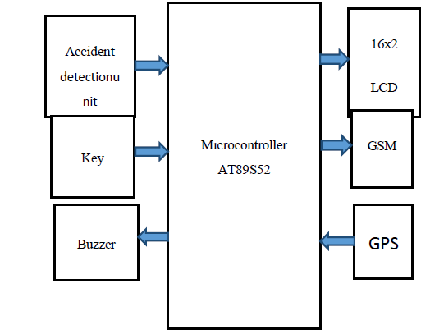

Figure 6 Real time Block diagram

# 2.2 The Proposed Disaster Detection System

The proposed methodology is the automatic system that will provide the solution to identify the scene of the accident. Actually in our proposed system we gave a very unique system that we used the GPS and GSM of our own mobile which makes it very inexpensive and reliable because in world there are almost 80% people who have Smartphone in their pockets. Although the techniques which we have discussed earlier also detecting the scene of accident but through the prescribed module of GPS and GSM which is surely expensive for any common person. Moreover why our idea is unique from the rest of the systems is due to the main following reasons.

# 2.3 How our idea is different?

## 2.3.1 Dynamic user friendly

In all other systems which we have discussed earlier there is not choice for user to change his/her contact number whom the alert notification will be transmitted. Since the emergency contact number is deployed by the just developer of that system. Hence the user of that system has to go to the developer for change of number which is ultimately irritated task as well as expensive for any human. But as far as concern is our proposed system we have given this vital feature in the hands of our valuable user. So our user can change contact number any time anywhere without wasting valuable time. That’s why our developed system is fairly unique from others in relevant to user satisfaction and user approach.

## 2.3.2 Smart phone’s GPS and GSM technology

We know that to detect the location of vehicle the Global Positioning System (GPS) is the only solution till now and Global System for Mobile Communication (GSM) is essential module for sending SMS to any contact. But unfortunately GSM is banned in Pakistan for security issues so we will use user’s smart phone to get location and also will use user’s mobile GSM for sending text message to the concerned person.

## 2.3.3 NO Application in Pakistan

Our proposed idea is unique because we notice many accidents in our surrounding in which lots of people expire due to no rescue aid in time. In Pakistan there is no such a system deployed which will be capable to alert the relative of vehicle’s driver. So due to no notification or alert in case of any emergency in Highways, several patients die in spite of this advance world.

# Chapter 3

Hardware and Software

Hardware and software modules are independently used to complete any embedded system for best working and giving high accuracy to the user without any kind of failure in progression of the system. To make our system effective we need to use some kind of our own designed hardware and software combinations which are essential part of our development.

# 3.1 Hardware

Hardware is any physical device used in or with your device, while software is a collection of code that is installed on your computer's hard drive. For example, the computer monitor that you use to read this text and the mouse you use to navigate through this web page is computer hardware. The internet browser with which you can visit this page and the operating system on which the browser is executed is considered as software.

Since we are working on embedded system which surely requires software as well as hardware. In our project we are using different types of hardware modules. So we will discuss all the details of modules used in our project along with their specifications and abilities.

## 3.1.1 PC

* **CPU:** Intel Core i5 – 3.2 GHz
* **RAM**: 8 GB
* **Video Memory:** Intel HD Graphics 5500 – 128 Mb

## 3.1.2 Printed Circuit Board (PCB)

Prior to the development of printed circuit boards, electrical and electronic circuits were wired point-to-point on a chassis. Actually, there was a metal frame or pan as a framework, sometimes with a wooden bottom was also used. Chassis was stuck by components, in case of when there was metal connection point on the chassis mostly. In that era the whole circuits were huge, capacious, heavy and ultimately weak which cause a very expensive product and the manufacturing was work rigorous.

Printed circuit board is very necessary part of every electronic project from large complicated machines to the very simple calculators. Due to high role of the circuit boards in almost every electronic development we have to choose the quality of PCB very wisely. So in our case we used a medium stranded circuit board which we sell in local market easily.

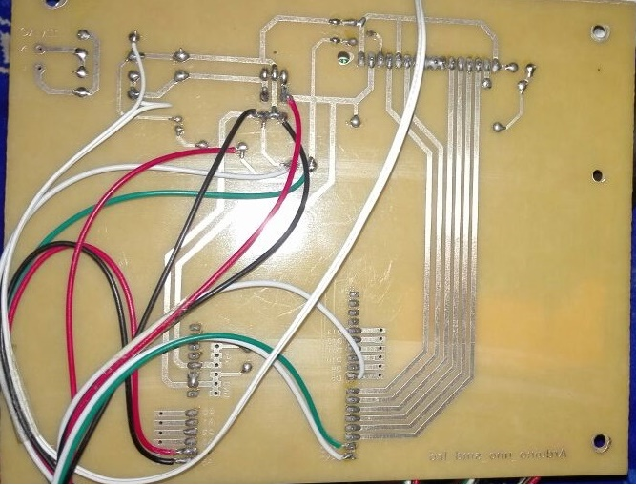

Figure 7 Printed circuit board

In a printed circuit board electrical components or electronic components are connected through traces, tracks and features carved from one to many points replying on copper sheets between an insulator substrate. Then the process of soldering come which actually tight the connections through soldering wire and soldering iron to electrically connect and make then firmly griped over the board.

All the simplest electronic products use the PCBSs. It may also be used in some electrical products which include junction boxes in passive states. The replacement of PCBs consists of a plug and a point-to-point construction; both times these are popular but are rarely used.

The designing of PCBs is done manually through efforts but the production can be automated as well as assembly. Most of the formats are made through specific CAD (computer-aided-design) software with different variety. A product cycle with PCBs is cheaper and faster than any other connection method, as the component is installed and operates in a single operation.

In production, there is no need to enter model again and again. Once it is done, we can manufacture much number of PCBs at the same time without wasting time. It is not necessary that always we need a large production. PCBs can produce in a low quantity which can be low in benefits.

## 3.1.2.1 Types of PCBs

PCBs have copper tracks to connect the holes where the various components are located. They are specially designed for each circuit and every construction is very simple. So the creation of the PCB requires special tools. The different types of circuit boards mainly contain the following.

* **Single Sided PCBs**
* **Double Sided PCBs**
* **Multilayer PCBs**
* **Rigid PCBs**
* **Flex PCBs**
* **Rigid-Flex PCBs**

## Single Sided PCBs

This single-sided printed circuit board contains only one layer of base material or substrate. One end of the substrate is covered with a thin layer of metal, usually copper, because it is a good electrical conductor.

As copper is a very good conductor so the one side of the substrate is covered with a thin layer of it to make it fast electrical conductor. In general, a protective solder mask is placed on the top of the copper layer and a final screen layer can be applied on the top to mark elements of the plate.

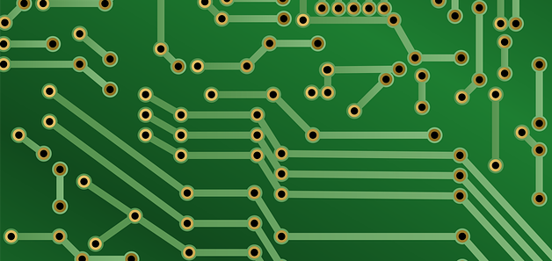

Figure 8 Single Sided PCB

On the only single side of this PCB there are several circuits and electronic components. Single sided boards are best for the use of simple electronic projects and mostly beginners uses these boards to design and implements components on it at first attempt. These plates tend to cost less for mass production than other types of plates. Due to the less and basic design restrictions these plates are rarely used even though these are low cost.

## Double Sided PCBs

Double sided PCBs are much better and popular than the single sided boards. In double sided boards the both sides are coated with conductive layers and also both sides contains elements for conduction of electricity. The connections for the both sides of the board are done by the holes in the print board. Surface mount technology is different from continuous technology, no wires are used. Instead, many small wires are soldered right on the board.

Mostly surface-mount technology is used in many circuits because it takes less space on the board which gives extra edge for better function performance and decrease the weigh with higher speeds than using of holes.

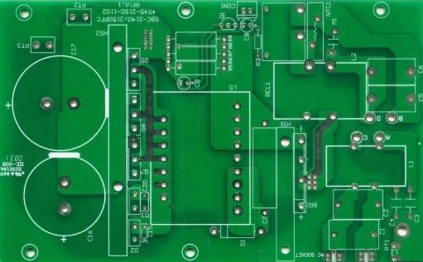

Figure 9 Double Sided PCB

## Multilayer PCBs

In a multilayer PCB it has more than two layers which increase the density and complication of the PCB model as we did not have in a double sided board. Through multi-layer printed boards it is very easy and good for the designers to make the design extra thick and highly merged, just because the more than one layer can be uses through predefined model of multilayer PCBs.

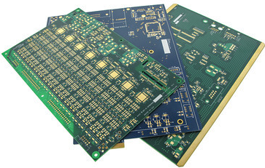

Figure 10 Multilayer PCB

Additional layers used in this design are power planes, which provide both circuits with electricity and also reduce the level of electromagnetic interference designed by design.

## Rigid PCBs

Printed circuit boards are not only categorized in terms of number of layers and sides. We also have different types of PCBs in terms of changing inflexibilities. Customers always think of the inflexible printed circuit boards in their minds as PCB. Rigid circuit boards are usually made from the hard materials like fiberglass due to which it can be not be twist and bent. Best example of the rigid printed circuit is the motherboard inside the computer tower.

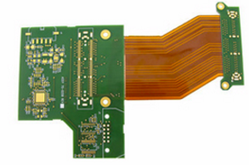

Figure 11 Rigid PCB

## Flex PCBs

Generally, the material used in flex printed circuit boards is the flexible plastics. This allows the basic content board to fit into the form so that individual boards cannot convert or change during print without a harmful circuit on the print circuit board. Although flex boards charge more for intentions and creations than PCB, they come with many advantages. For instance, they can restore heavy or large wiring in high gear such as weight and space matter. The flex board can also come up with three types, **single-sided, double-sided or multi format formats**.

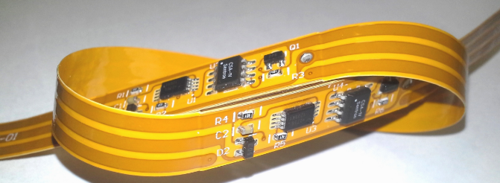

Figure 12 Flex PCB

## Rigid Flex PCBs

Hard flex boards integrate technology combined with both flexible and hard circuit boards. An easy-to-use flexible board consists of a stringent circuit board that connects to a flex circuit board. If the application is requested, these boards may be more compounds.

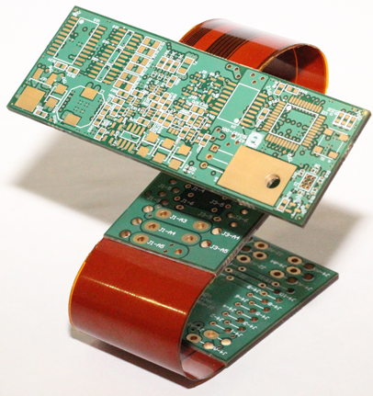

Figure 13 Rigid Flex PCB

## 3.1.3 16x2 LCD

Liquid crystal displays (LCDs) are widely used in all types of projects where we need to display some sort of data to the user as in calculators, microwave ovens and other electronic appliances. There are lots of types of LCDs available in market to fulfill our requirements. In our project we are using a very simple and common 16x2 LCD display.

In 16x2 LCD there can be shown 16 characters per line. There are two lines in this LCD. It consist of 16 pins and two registers namely command and data. In command register we insert instruction to be taken by LCD like clear screen, initialize screen and cursor position. While data register is responsible for the data storage to be display on screen.

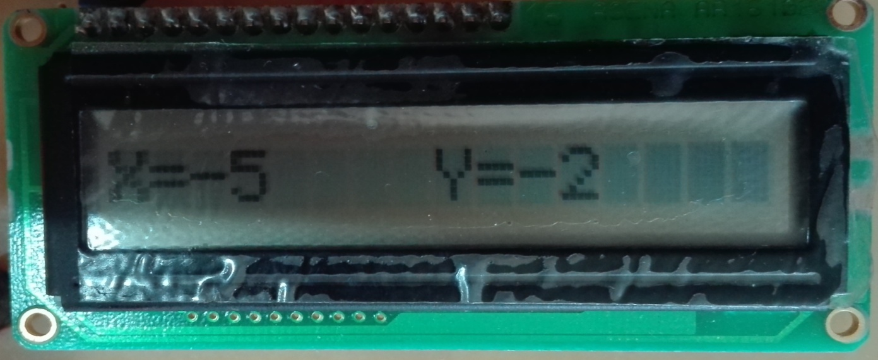

Figure 14 LCD 16×2

## 3.1.4 Arduino UNO REV 3

From the birth of human till today mankind always tried their best to overcome the burden of manual force of people. To keep in mind these continuous struggle scientists always invented many products which converted human practical burden on machines through hardware and software modules. Arduino is very simple and common way to control hardware through software instructions.

Arduino UNO is microcontroller board based on the Atmega328P. It has 14 pins, USB connection, reset button and power jack. There are many other microcontrollers available in markets along with microcontroller platforms for embedded systems working. Parallax Basic Stamp, Netmedia's BX-24, Phidgets, MIT's Handy board, and many others offer similar functionality.

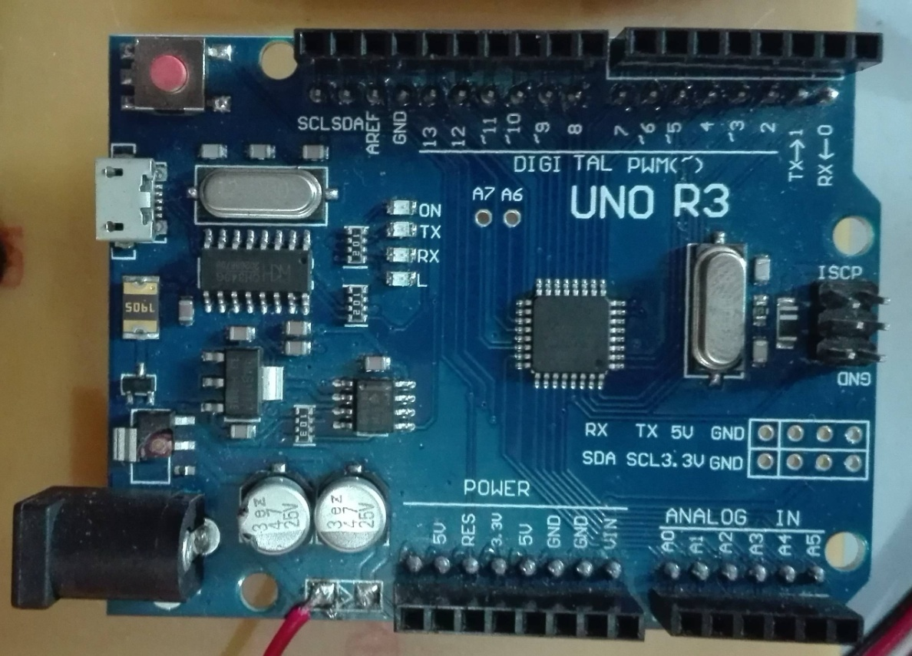

Figure 15 Arduino UNO Rev 3

In other words Arduino is the key point for using the microcontroller and their features in your way. We can do multiple activities by using Arduino which reduces the work force as it does the whole physical activities. Arduino is the best solution for teachers, students and the seekers of the embedded systems.

### 3.1.4.1 Why we use Arduino?

* The Arduino boards are inexpensive among all other microcontrollers exist in markets.
* We know that most of the microcontrollers are platform oriented while Arduino is very efficient on any kind of operating system like, windows, Linux and IOS.
* The Arduino software (IDE) is easy to use for beginners as well as flexible for advance level students and so perfect for teachers.
* Best part of the Arduino is that it is open source tool, which is provided by expert programmers as extension.
* Arduino uses the modified version of C which is base of the any programming language.
* The plans of the Arduino boards are published under a Creative Commons license, so experienced circuit designers can make their own version of the module, extending it and improving it.
* Microcontroller ATmega328p used in Arduino UNO Rev 3 is an 8 bit device as architecture.
* ATmega328p uses three types of memory.
* **Flash memory:** 32 KB nonvolatile memory**.** This is used for storing applications, which explains why you do not have to upload your application every time you remove Arduino from the power source.
* **SRAM memory:** 2KB volatile memory. Run time variables are stored in this memory.
* **EERROM:** 1KB nonvolatile memory. This is used for storing the data that must be stored weather it is power on or power off.

## 3.1.5 Bluetooth Module HC-06

We have different ways to connect Arduino with our Smartphone to give and get input and output respectively. A very simple and common way is through Bluetooth module. Since we need to exchange data for short range, means just some meters, and also it is very inexpensive and simple to use that’s why we used Bluetooth instead of any other technology. In our project we used HC-06 which is very efficient with Arduino and other microcontrollers. Furthermore we will discuss later how the HC-06 works with Arduino.

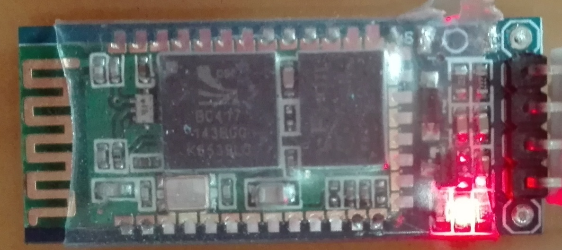

Figure 16 Bluetooth Module HC-06

## 3.1.6 Accelerometer MPU 6050

An accelerometer is a device that measure proper acceleration. The proper acceleration might be the straight or a free fall situation like free falling from upward to the center of the earth. Here in our development of Disaster detection system we used MPU 6050 because it is inexpensive and easy to program with other modules like Arduino and Smartphone. In our case we use accelerometer for the detection of vehicle’s axis varying throughout the movement.

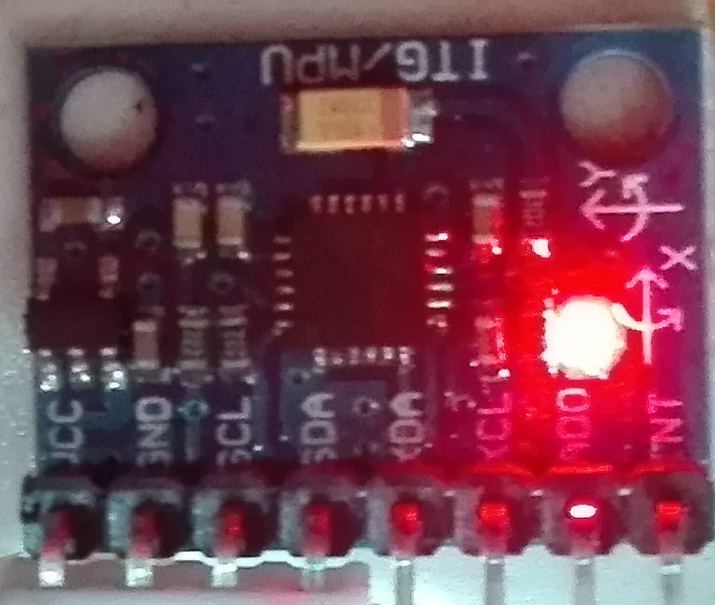

Figure 17 Accelerometer MPU 6050

In a moving vehicle crash not only occur when we have a collision with another vehicle but it may also occur when we have no proper balance in right and left sides of the vehicle. Sometimes a vehicle may move on the footpaths due to which major accidents occur. Since when a vehicle have lost his balance then the angle of the vehicle definitely changes in both ways latitude and longitude, hence the chances of accident are high.

## 3.1.7 Vibration Sensor

There are lots of types of vibration sensors for detection of vibration in any product. Vibration sensors are used in various fields of science and technology to identify whether any obstacle is in constant acceleration or been stuck to any other obstacle. As for concern to identifying the intensity of vibrations lot of sensors are available in market with low sense to very high sensitivity.

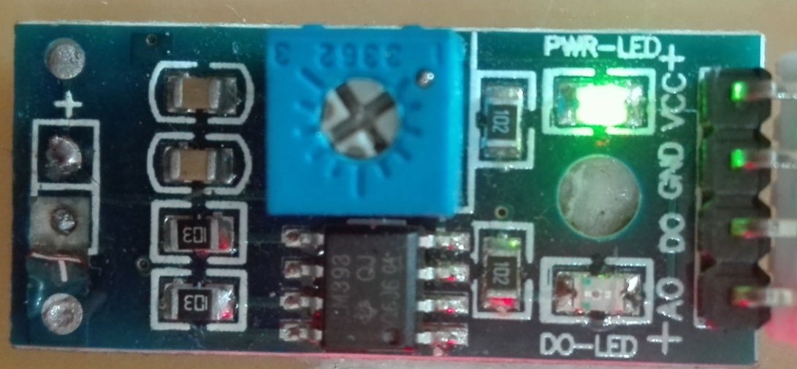

Figure 18 Vibration Sensor

## 3.1.8 Battery

We know that to run any kind of hardware we need power. So we used simple DC battery in our project to run electronic circuit. We need just 5V to run our modules, but since we need full 5V for smooth working, so after few moments battery will be down in power due to consumption. To eradicate power low problem we used two batteries of 4V having total 8V current. To meet our requirements of 5V we will down the voltage by 8V to 5V through techniques.

Figure 19 Battery 4V

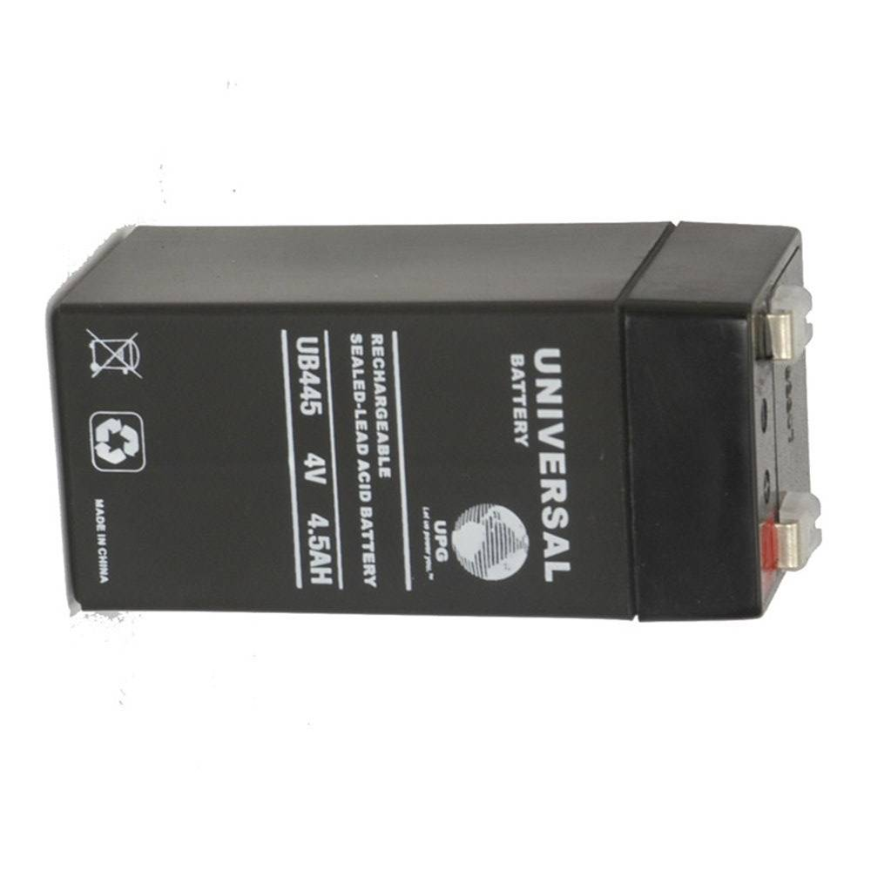

## 3.1.9 Regulator LM7805C

We have earlier discussed that we need full 5 voltages for the working of our project but we did not have 5V battery in market, we used two batteries each of 4V which yields total 8V. So we need to drop the voltage till the 5 voltage. For the sack of this purpose we used regulator LM7805C. A regulator is an electronic device which is used to maintain the circuit voltage within the acceptable and prescribed range of voltage. A voltage regulator plays a very vital role in the circuit to keep the output voltage within the acceptable and tolerated voltage by the circuit. The idea behind the using of LM7805C came because of it is low cost and durable in use. It gives best performance and accuracy in terms of voltage conversion and voltage level.

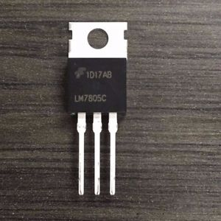

Figure 20 Regulator LM 7805C

## 3.1.10 Capacitors

A capacitor is an electronic device which is used for short time current storage. Actually capacitors are used for the backup of the energy in form of electric current when the batteries are changed to avoid the loss of the important information in volatile memory. So capacitors are mandatory parts for any electronic circuit. In our project we used overall four capacitors having different values. We used two capacitors of 100nf, third capacitor 680µf and last one of 470µf in different places which will be explained in detail in methodology chapter.

## 3.1.11 Resistors

A resistor is an electrical device used for the resistance in the flow of the current in a circuit. We use various types of the resistors in our circuits to maintain the current level till our required limits. High power resistors are used for the dissipation of the many watts of the energy in heat. In our project we used two types of resistors. One for the LED light having resistance of 680KΩ and second one potentiometer for the contrast adjustment in LCD having 100KΩ.

## 3.1.12 Switch and LED Bulb

Switches are used for the controlling the current in the certain circuit to avoid wastage of the battery current. In our project we used a simple switch to control the circuit. One thing more for the identification of the current running in the circuit we will use a simple LED light of color red.

## 3.1.13 Android Smart phone and data Cable

We have explained in chapter one that our project is consisted of an android application installed in the smart phone of the person driving the vehicle. So for the sack of the application perspective we need an android smart phone. We used a data cable for the dumping code into Arduino.

## C:\Users\ali84\AppData\Local\Microsoft\Windows\INetCache\Content.Word\Remax-Platinum-Wing-Type-C-Cable-Fast-Charging-Data-Cable-for-Android-Smart-Phone-for-LetvMI-7.jpg

Figure 21 Android mobile & data cable

## 3.1.14 Car Model

In every kind of project there is a necessary part of presenting demo of that project before the people to evaluate the efficiency and suggest improvements. Our project is pivot of the vehicle for which we are going to develop the system of disaster detection. So we made a roughly model of a car to deploy our project and present in front of evaluating committee. Keep in remember that our project is for real use no just demo on small tinny vehicles.

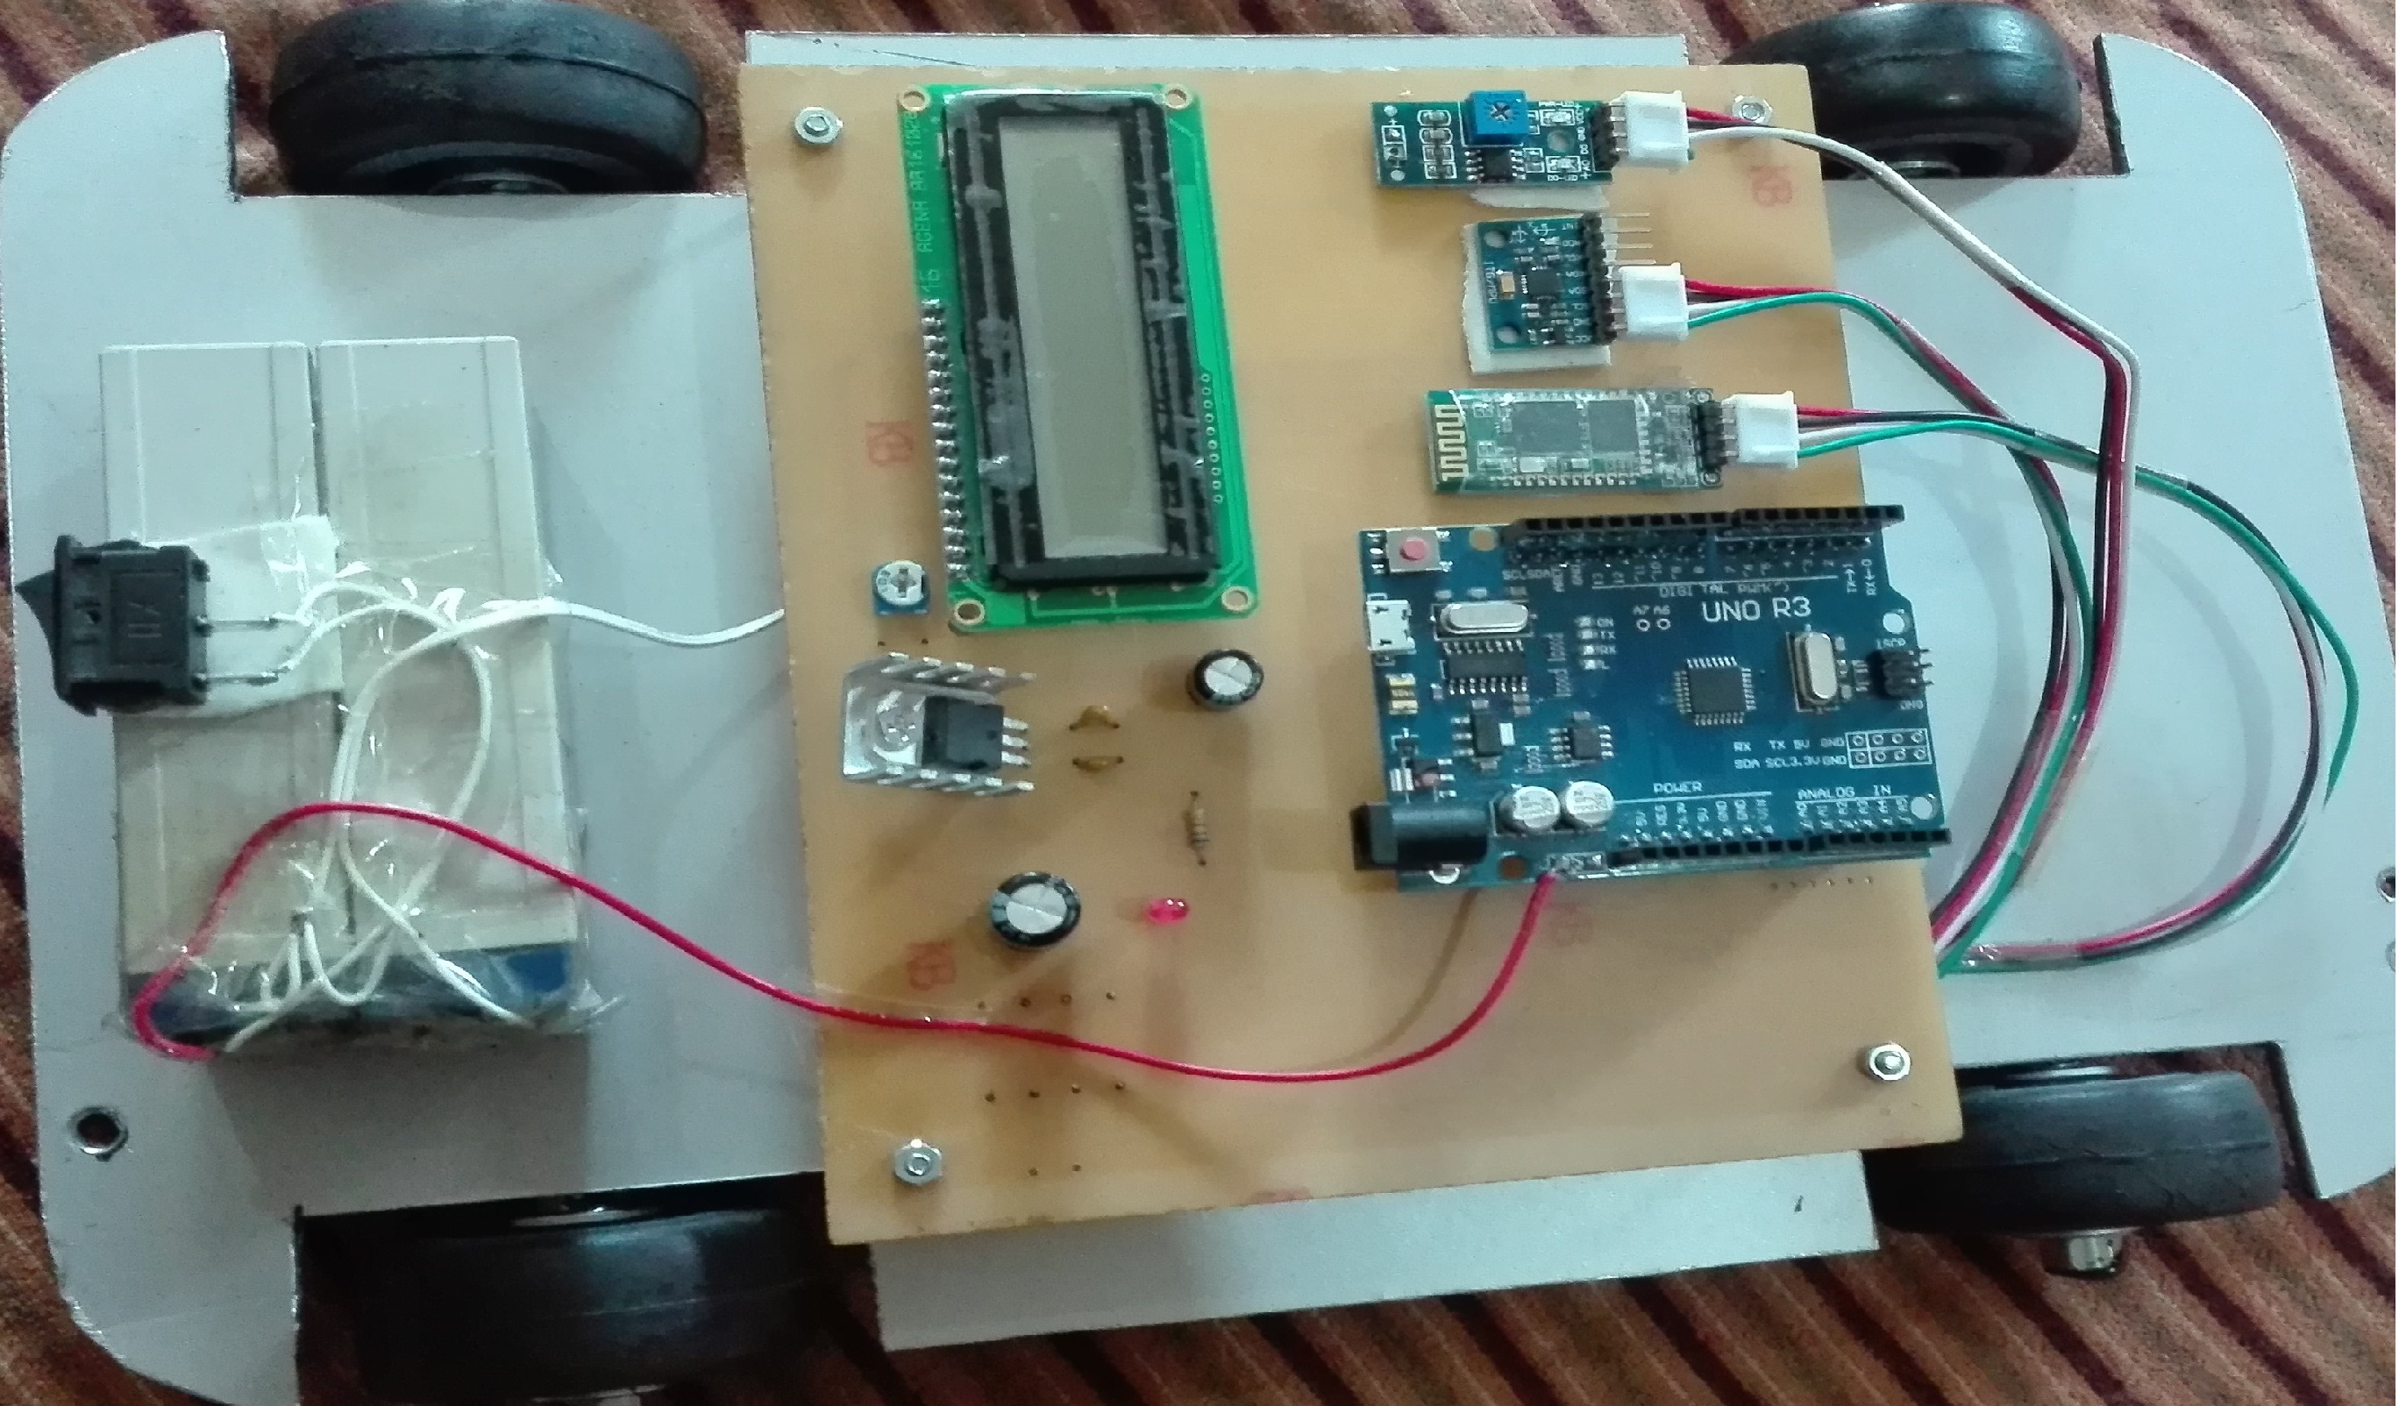

Figure 22 Car Model

As we can see in figure 22 that all the components are placed according to the PCB block diagram. There is no complexity in connections and in wires.

## 3.1.15 Soldering tools

To make our circuit complete we need to connect different wires, pins and points to another. So for the purpose of making connection tight and hard we used solder iron, soldering wire, wire cutter and solder for long lasting connections.

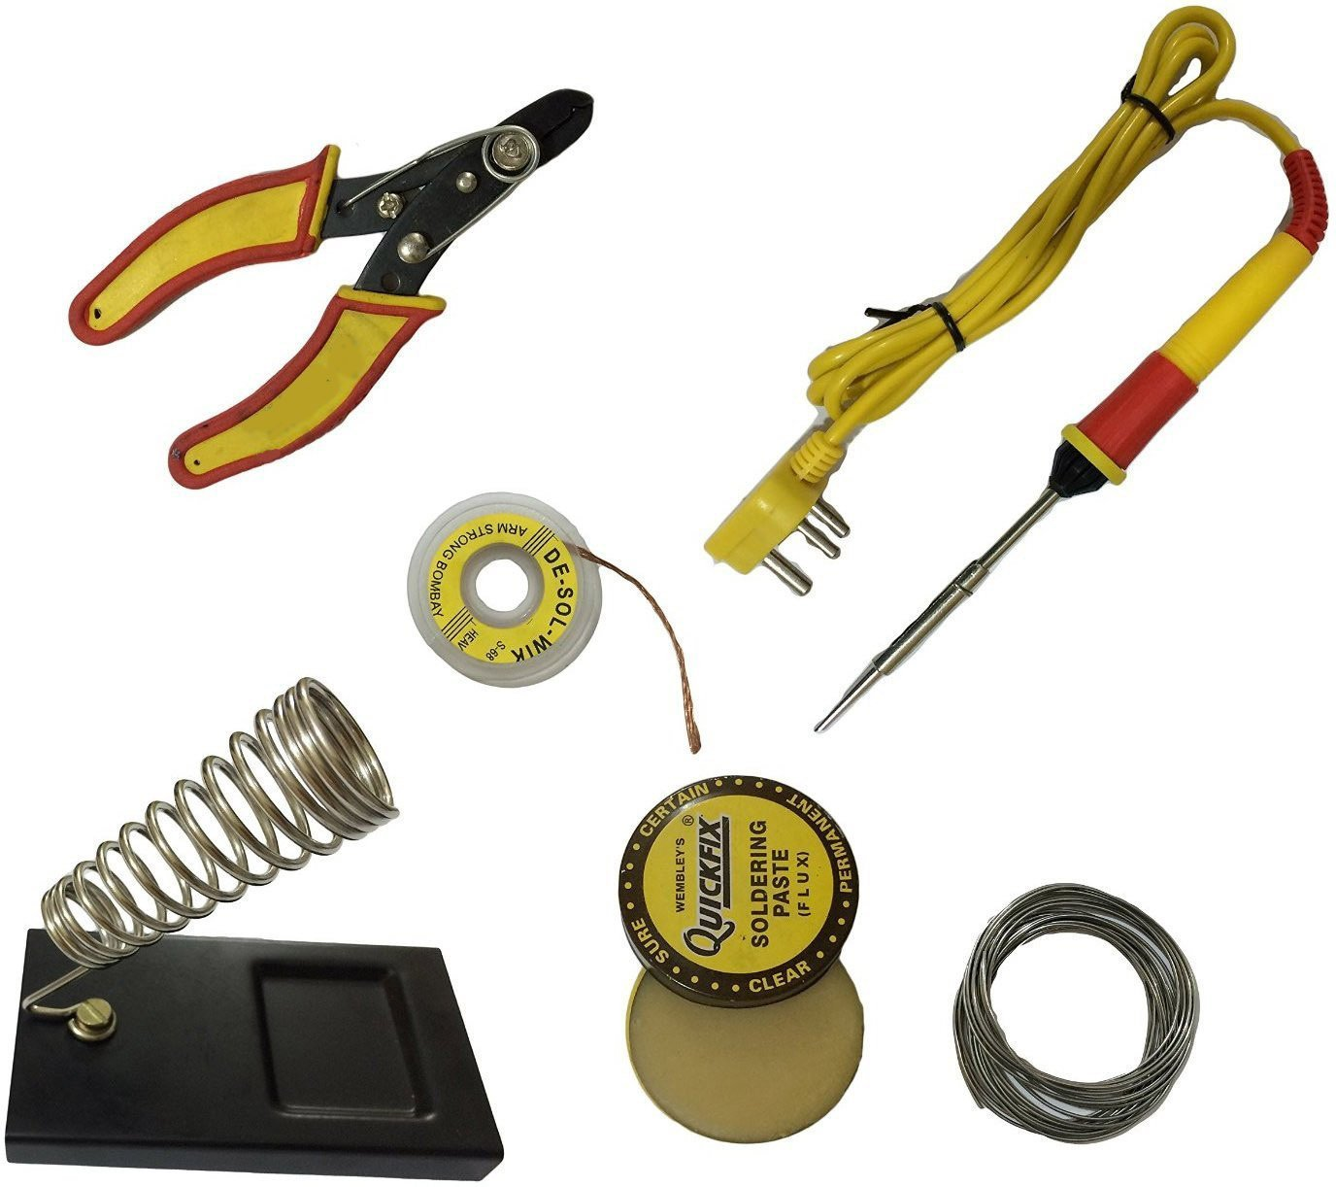

Figure 23 Soldering Tools

# 3.2 Software

In any living substance there are several things working behind the scene. Some of which we are clearly familiar with but most of the others we even never noticed of their presence. In simple words physically visible things have slightly more attraction than invisible behind the door working substances which may be in different in working as well in placing. So in our project we have both visible and invisible modules like hardware and software respectively. Actually software is the instruction and information on behalf of any hardware works. We used Microsoft Windows 10 in our operating system.

## 3.2.1 Microsoft Visual Studio

We used visual studio community 2017 for the android application as our working environment. To create front end of the application we used XML with predefined visual studio’s feature to explore more creativity and efficiency. We worked with c# to handle the back end using Xamrine platform which is also a very efferent and latest platform in android development. Due to the extra ordinary feature of being cross platform development in Xamrine compelled us to go through that way. [8]

## 3.2.2 Arduino Software

We have to deal with the coding of the Arduino for the working of the hardware. There is well performed software by the Arduino developers to dump the code in the Arduino. Here we have used latest version of the Arduino 1.8.5. In Arduino we use the modified version of the language C and C++. [9]. That’s why for any kind of user and developer it is very easy to use an code the Arduino by himself with little knowledge of C and C++.

# Chapter 4

Proposed Methodology

We know that every development of any project is based on different techniques, methods and methodologies. Our project will be able to detect the accident and will transmit a SMS to loved ones along with precise location, it has been discussed earlier but how we will achieve our goal of saving people from severe damages is also important to know and understand. In this chapter we will discuss the whole process for developing the system in detail.

Since we are working on an embedded system that consists of both hardware and software part. In section of hardware we have given the names of hardware modules used in our system with brief introduction and specifications. We have divided our project into two main parts Hardware part and Software part. Now we will discuss both parts development processes in details.

# 4.1 Hardware development process

In context to hardware development process we had to go through different stages to complete our hardware part. As we have earlier discussed that the purpose of hardware part is to get the angel of vehicle with respect to x and y coordinates, and vibration output when the vehicle collide with another obstacle. To explain the further process of Hardware development process we would like to give a view of Block Diagram of the project.

## 4.1.1 Block Diagram

In any project the first step is considered to draw the block diagram of it with adequate modules to narrate the project in decent view. Actually the connections of all used modules are shown and a judgmental thought in first view is given to the reader for understanding of project development.

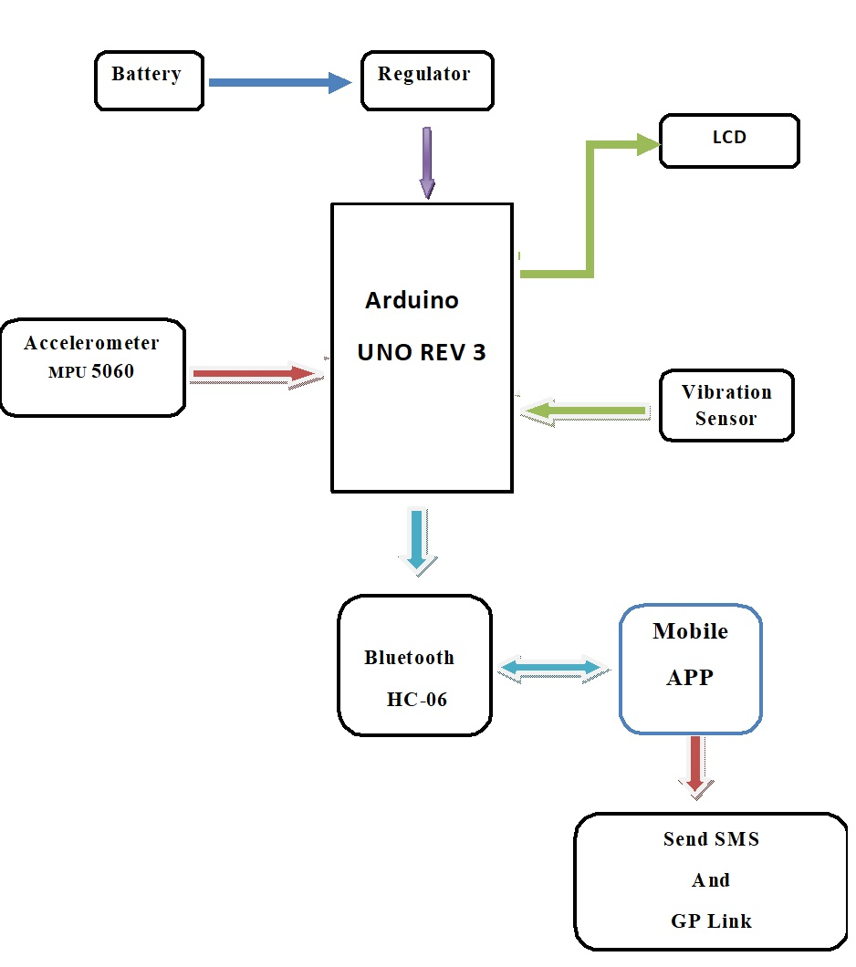

Figure 24 Block Diagram of DDS

## 4.1.2 Printed Circuit Board (PCB) block diagram

Printed circuit diagram is the overview of the whole modules working on PCB board. Actually the PCB is the main item in any circuit of electronics. Circuit boards (PCBs) have long been the basis of electrical engineering and serve as the "brains" of any powered device. The design of PCBs goes to electrical engineering as HTML to web development - the backbone that makes it all possible. That is because no device works without a PCB. From mobile phones and remote controls to robotics and toys, PCBs provide electricity and connectivity between the components of a device, allowing it to function as it was designed.

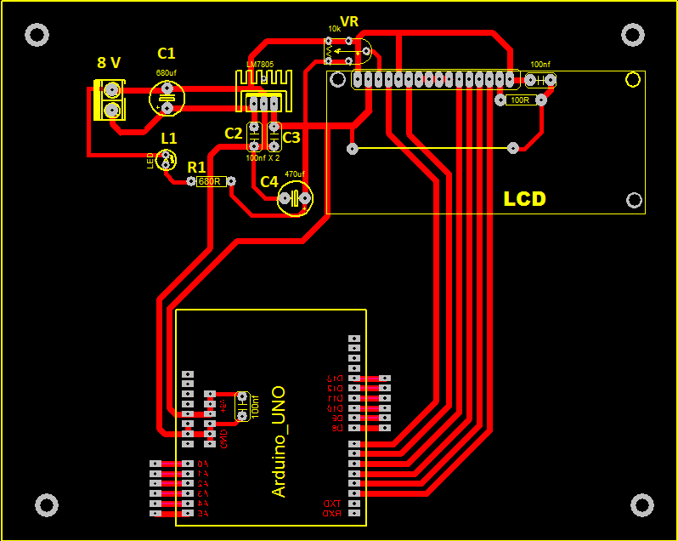

Figure 25 PCB Diagram

## 4.1.3 Configuration of LCD with Arduino

As we have earlier discussed that LCD works on the basis of pins which are 16 in number having different uses and their specifications. The LCDs have a parallel interface, which means that the microcontroller must manipulate multiple interface pins at the same time to control the display. The interface consists of the following pins:

* A **register-select (RS**) pin that determines where in the memory of the LCD where you write data to. You can either select the data register that fits the screen, or an instruction register, where the controller of the LCD screen searches for instructions on what to do.
* A **Read/Write (R/W)** pin that selects reading mode or writing mode.
* An **Enable pin** that enables writing to the registers.
* **8 data pins (D0 -D7).**

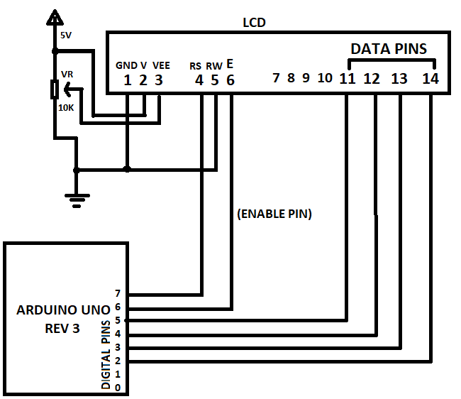

Figure 26 Configuration of LCD with Arduino

In our project we used digital pins 2, 3, 4,5,6,7 from the Arduino while the other pins from LCD are GND, voltage and contrast.

**Data pins from LCD:** We used pin numbers 11,12,13,14 from LCD as data pins and connected them with four pin numbers 2,3,4,5 from Arduino respectively.

**Enable Pin:** Pin number 6 from LCD that is enable pin is connected with pin 6 from Arduino.

**RW Pin**: Since here we just want to show the data on the screen means that output display is required i.e. in our case in form of X and Y coordinates. Hence we gave 0V means GND because if RW pin is given Low voltage then it works as write data on LCD.

**RS Pin:**  This pin is responsible for the mode of choosing register for data or the instructions. So we connected this pin (4) with pin (7) from Arduino.

**VEE Pin:** Pin number 3 which is for the contrast in LCD. Here in case we used 10K variable resistor which is almost 50% of the contrast.

**VCC Pin:** Pin number 2 is for the full required voltage for LCD i.e. 5V. So we connected this pins straight with the 5V supply.

**GND Pin:** Pin number 1 is use as ground pin in LCD so, we connected it as ground voltage.

**LED+:** This pin which is 15 in umber is responsible for the backlight of the LCD

**LED-:** Pin number 16 is been grounded which yields the effect in backlight.

## 4.1.4 Power supply distribution

We know very well that to run any project we need proper power in terms of electricity. In our project we have a choice for power from direct Arduino using a 5V power source or through the DC battery of 5V. As we know that in market there are mostly 4 volts batteries available but we need proper 5 voltages for the whole project so, we used two batteries instead of one to carry out our burden of electricity consumption.

First we used a capacitor C1 of 680 µf for the smoothness in current which is usually used in parallel series. Now we need to reduce the current in the circuit till the 5V. For this purpose we used regulator LM 7805C which will reduce current from 8V to our required 5V. In regulator LM 7805C we have three pins for input, ground and output voltage. We directly connected the negative terminal of the input current with the middle pin of the regulator which is ground pin and same way the positive current is connected with the first pin of the regulator which is the input pin VI of the regulator. Finally we got the output 5V current from the third pin of the regulator which is always used as output current pin.

We used two small capacitors of 100 nf one C2 with the ground and output 5V of the regulator and second C3 with the input 8V and the ground. Now we connected the direct ground current with the Arduino GND pin through trace. After the capacitor C2 and C3 we used another capacitor C4 to which we attached a resistor R1 680 Ʊ to illuminate the LED light whereas the other end of LED light is attached to the main 8V negative point of current.

## 4.1.5 Bluetooth module working

We know that for the communication between the hardware and software one thing is very popular to use that is Bluetooth module. We used HC-06 module in our case as it very updated and gives good performance in data transmitting. First of all we would like to describe the distribution of power to the Bluetooth module. In addition to supply the power we connected wire of color red with 5 voltage positive terminal and the other wire having color black is been connected with the ground voltage of the whole system on a certain point.

Now the turn is for the connections of the Bluetooth module with the Arduino pins. We can see that there are two remaining terminal on HC-06 having names TXD and RXD. These are the dedicated pins for the Arduino connections in any circuit. Here we will connect the TXD pin from Bluetooth module with the Arduino pin having name TX and same procedure will be done with the other pin of Bluetooth module having name RXD will be connected with RX pin of Arduino. So this is all for the working of the Bluetooth module with the Arduino.

## 4.1.6 Setting up Vibration sensor

There are lots of occasions when we will be notified about the crash of the vehicle through the vibration sensor attached in our project through circuit. Actually the vibration sensor works on the technique that whenever it is given low voltage on some certain dedicated point, it will notify to the Arduino that the problem has been occurred and kindly reach the spot as soon as possible.

Now we will describe the circuit of the vibration sensor for our working. As all the electronic components require the voltage of both types to complete circuit means positive and negative. So we connected the red and beck wires of the vibration sensor with the positive and negative 5V. Now we connected the last one wire of vibration sensor for giving signal to the Arduino with the pin number D8 in digital pin side.

## 4.1.7 Accelerometer configuration

In a moving vehicle crash not only occur when we have a collision with another vehicle but it may also occur when we have no proper balance in right and left sides of the vehicle. Sometimes a vehicle may move on the footpaths due to which major accidents occur. Since when a vehicle have lost his balance then the angle of the vehicle definitely changes in both ways latitude and longitude, hence the chances of accident are high.

Our concern with the accelerometer is to get the longitude and latitude of the moving vehicle for the detection of accident and notify the families of the concern persons. Since where we just need the X and Y coordinates of the vehicle so we will use the two pins as well as the power pins positive and negative.

We connected the Vcc pin of the accelerometer with the 5 voltage of the battery at the one end of the capacitor C4 and the GND pin with the other end of the C4 as ground terminal of the whole circuit. Now for the purpose of the getting X and Y coordinates we will connect the SCL pin from the accelerometer with the A45 pin and the SDA with the A4 from the Arduino analog pins.

### 4.1.8 Assembled Hardware Unit

After all the working in power and placing the modules we have the completed hardware unit. All the modules are in their fitted potions and no short circuit is in any case.



Figure Final hardware unit

# 4.2 Software Development Process

A part from the hardware development process we will also have to deal with the software methodology used in our project. As we have already discussed that we will build an application for the driver of the vehicle installed in his/her android smart phone. Since the purpose of the mobile application is just to get notification from the hardware part and send a SMS to the concerned person with the precise location of the accident spot, hence we will develop a very simple and easy to use for every kind of person driving the vehicle irrespective from the technical background level.

## 4.2.1 Main Activity

There are several parts of an Android application with different perspectives and for various strategies. In an android development through Microsoft visual studio we have a main global window called as main activity which includes all other sub activities of the application from. In our application we have used different things explained as follows.

**Used Libraries:**

**using System;**

**using Android.App;**

**using Android.Content;**

**using Android.Runtime;**

**using Android.Widget;**

**using Android.OS;**

**using Android.Bluetooth;**

**using System.Linq;**

**using System.Threading.Tasks;**

**using System.IO;**

**using Android.Telephony;**

**using System.Text;**

**using Android.Locations;**

**using Android.Util;**

**using System.Collections.Generic;**

**Namespace and Overview of Classes**

We used namespace**” DisasterDetector”** with the following classes.

**Public Class main Activity:** The main class of the every application consisting of all the code written within it.

**Public class BluetoothConnection**

For the sack of Bluetooth using between hardware and mobile application.

**Public class** For the get and set the values of the latitude and longitude.

## 4.2.2 StartPage Activity

At very first we have a start page having a progress bar which may be referred as fake loading just to make interesting and attractive to our application. The coding behind this start page is very simple and uses given built-in functions. Here we used just a color in the background of this activity.

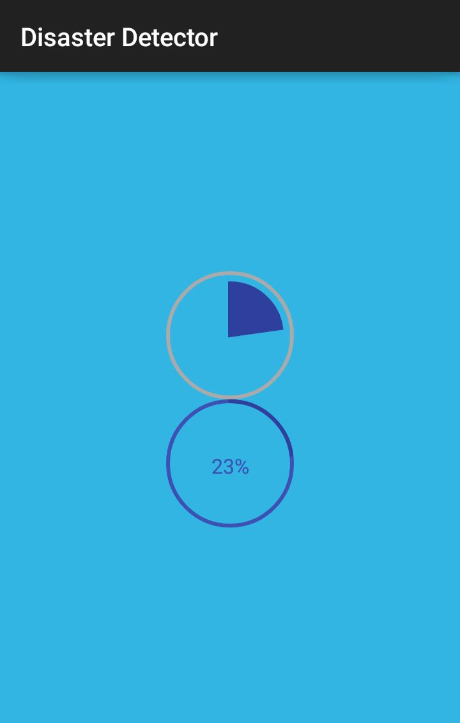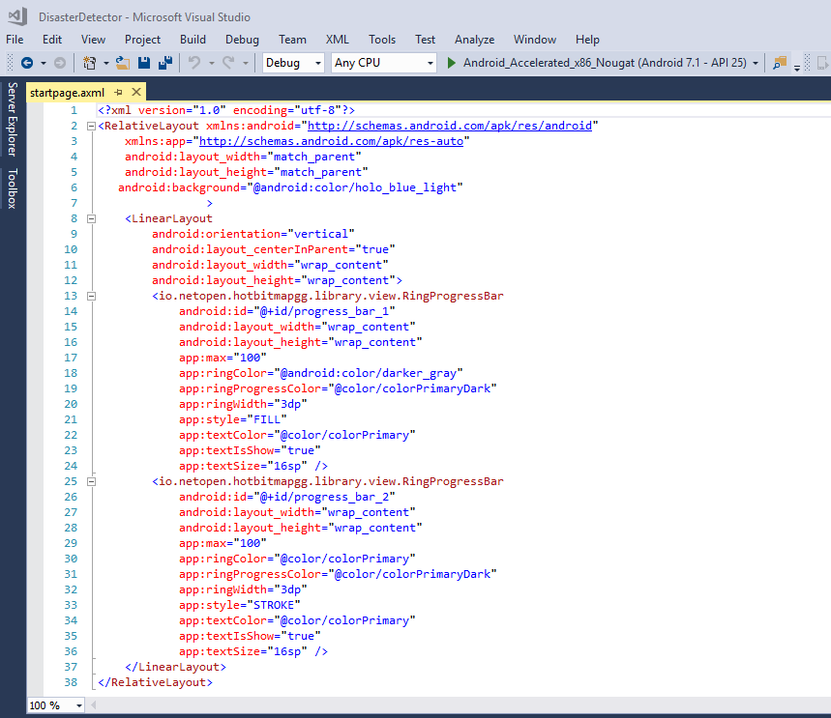

Figure 28Start page code & design view

## 4.2.3 Main Activity

After the loading page we have the main activity which also called as the front end work for the user because the front is the just view which is visible for the users. In main activity we have different types of views.

**Text view**: to display the any kind of text we use text view within the linear layout.

**Edit text:** for the sack of writing test in a given field.

We have two entering fields for data from user as the Name of the user and the contact number of there person whom you want to send alert message in case of emergency.

As soon as the Bluetooth module will be connected with the application there will be two more text views for the display of latitude and longitude.

Figure 29 Main front end code and GUI

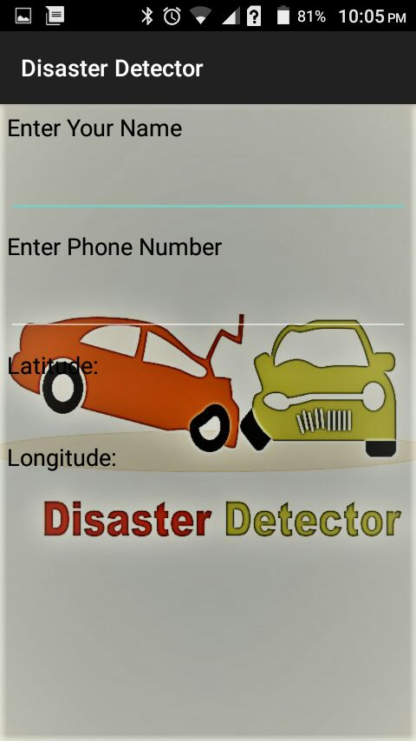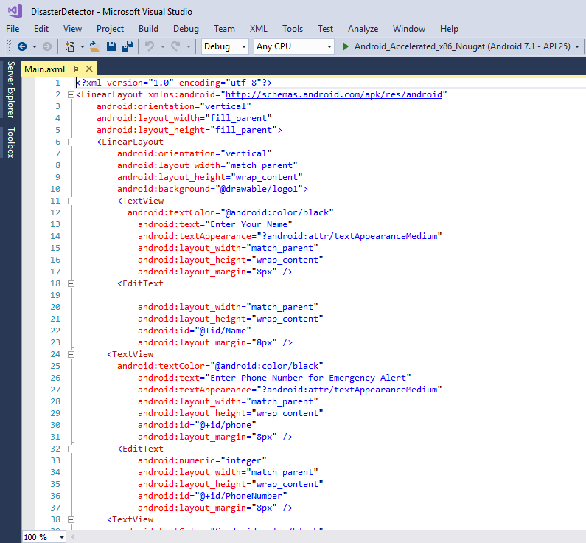

## 4.2.4 Working of Code from start to end

First of all we included the libraries required for our applications which we have already written in above headings. Then there is namespace having name Disaster Detector. After that we have a main class named as mainActivity in which at very first we have called the **bluetoothConnection ()** function. Then we got the attitude and longitude from the location manager by using mobile’s GPS. We have then intended to connect the Bluetooth module with our app using API. Here we also used the **catch ()** and **try ()** functions according to the scenario till we have not connected with our Bluetooth module.

Then we have initialized the location manager which is used for getting the coordinates of current location in terms of latitude and longitude in degree. If there is any problem in provided network then a toast message will be displayed on mobile screen that is **"The Network Provider does not exist or is not enabled."** After the successful connection with the Bluetooth module we also display toast message that is **“Successfully connected.”**

Then we moved on towards the message sending API and its functions. For the sack of message cache memory we used buffer size of 1024. Then we have the signal from the Arduino in way that if the response functions contains “;” then the SmsManager will be asked for sending message contains the name of the user and the message came from Arduino plus the here mentioned message and the URL for the Google maps **("http//maps.google.com/?q=")** then the values of latitude and longitude.

## 4.2.5 Manifest Permissions

We know that to do some activities in a smart phone we have to take certain permissions from the mobile. Actually the permissions are the authentication steps which we ask to the mobile that we need to use some certain tools for our working so kindly allow us to use these tools.

### Bluetooth

As we are using the Bluetooth for the connection so need to get access form the mobile that we want to use the Bluetooth settings. So this permission allows application to connect the paired Bluetooth devices.

### SEND _SMS

We know that in our system we have the feature and maybe said that the basic purpose to send the alert message to the loved ones in case of any emergency using mobile’s SMS. So we need to get permission for sending SMS from mobile. So this permission allows an application to send a SMS.

### Read _Phone_State

Allows read only access to phone state, including the phone number of the device, current cellular network information, the status of any ongoing calls, and a list of any phone contacts registered on the device[7].

### Access_Course_Location

Another very important feature of our app is to send the location of the accident spot. So for this purpose we need to have permission from mobile for the approximate location. That’s why the access course location permission allows the application getting the approximate location of the mobile.

### Access_Fine_Location

Same as the course location the access fine location is for getting the precise location of the mobile where the accident has occurred. So this allows application to get the precise location of the current point.

### Internet

Since the precise location cannot be measured without internet so we it also. So the internet permission will allow the application to open the network socket.

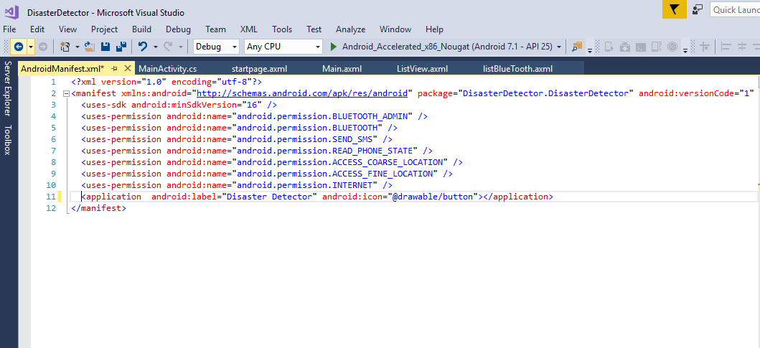

Figure 30 Manifest Permissions

## 4.2.6 Dumping the code into Arduino

As we have already discussed that we will use Arduino Uno 3 for the purpose of handling the hardware components. So we also know that Arduino need some instruction in form of code in some certain language. Here in case of Arduino there is well developed language which the modified version of C.

### Code for Arduino

We have used the following libraries in our code for smooth working of Arduino.

* **#include <Wire.h>**
* **#include <TimerOne.h>**
* **#include "Arduino.c"**
* **#include <LiquidCrystal.h>**

We used six pins of the Arduino for the display on LCD.

**LiquidCrystal lcd(7, 6, 5, 4, 3, 2);**

Then we initialized the Accelerometer MPU 6050 and got the X and Y coordinates values of the vehicle and initialized the values with AcX and Acy. Then we converted the X and Y values into degrees by using following formula.

* + **AcX = map(AcX, -16000, 16000, -90, 90);**
  + **AcY = map(AcY, -16000, 16000, -90, 90);**

Then we used pin number 8 of Arduino for the sack of input from the vibration sensor.

* **pinMode(8, INPUT);**

Now the rows and columns of the LCD set up printed a message of initialization then give a delay of 5oo mile seconds and then clear the LCD screen. Following commands are used respectively.

* lcd.begin(16, 2);
* lcd.print("Init....");
* delay(500);
* lcd.clear();

Then we displayed the current vales of X and Y coordinates on the LCD screen after we setup the cursor of the LCD using following code.

* lcd.setCursor(0, 0); lcd.print("X=");
* lcd.print(AcX);
* lcd.setCursor(0, 1); lcd.print("Y=");
* lcd.print(AcY);

Now the task is to check the condition for the X and Y coordinates of the vehicle and sent the signal to the mobile application as an alert message to loved one when the angle is more than 50 degree. The following lines of the code will do a very vita work for us.

* + - if (AcX < -50) {
      * Serial.println("Accident occur");
      * delay(500);
      * Serial.print(";");
      * while (1);
    - }
    - if (AcY > 50) {
      * Serial.println("Accident occur");
      * delay(500);
      * Serial.print(";");
      * while (1);
    - }
    - if (AcY < -50) {
      * Serial.println("Accident occur");
      * delay(500);
      * Serial.print(";");
      * while (1);
    - }

Now the turn for getting input from the vibration sensor and sent it to the pin number 8 of the Arduino as low voltage seems to be the alert message.

* + - * if (digitalRead(8) == LOW) {
        + Serial.println(" Accident occur");
        + delay(500);
        + Serial.print(";");
      * }

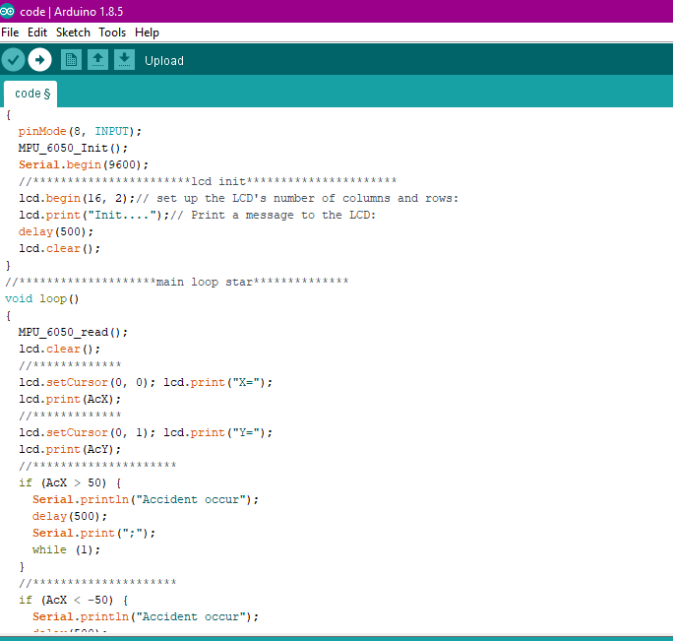

Figure 30 Arduino code (a)

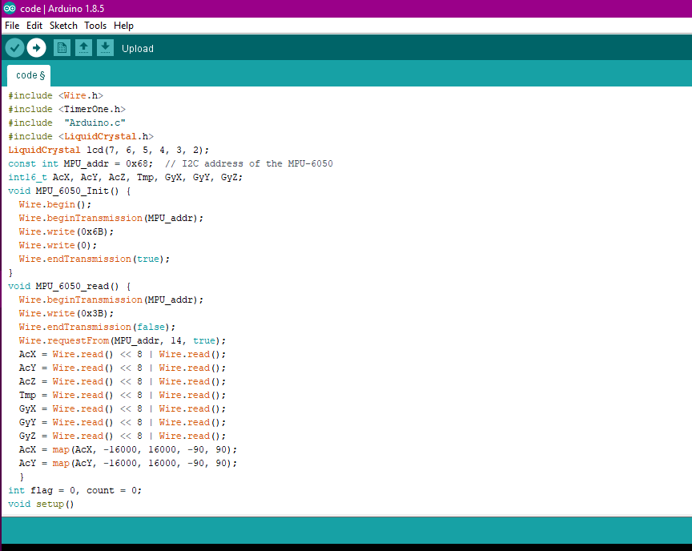

Figure 31 Arduino code (b)

# Chapter 5

Experimental Analysis

None of the product can be declared as a good or bad till we have not tested in the different scenarios and conditions for which it is made of. Because we have to tackle with the various environments during the real time using of our project. So in this chapter we will explain situations in which we tested our system with precise results.

# 5.1 Test Case

Consider that someone is going on a trip towards the Northern areas of our beloved country passing through the twisted roads. Unfortunately at a certain point a high speed car came from the opposite side and collides with the vehicle and driver got serious injuries. Since there is no symbol of population near that spot and the opposite car driver just ran away from the place in fear being caught by the police. However good news is that the vehicle has our Disaster detection system due to which man survived and living life happily without any fear of more crash. How our system worked is explained in following steps.

## 5.1.1 Pairing the Bluetooth module with smart phone

First of all the Bluetooth module of the hardware paired with the smart phone of the driver. For this purpose switched on the circuit through the switch placed near the batteries. Then went to the settings of the mobile and turn on the Bluetooth and searched for the new device. In the list we have the name of Bluetooth module (HC-06). Then paired with the HC-06 which meant it is connected with it.

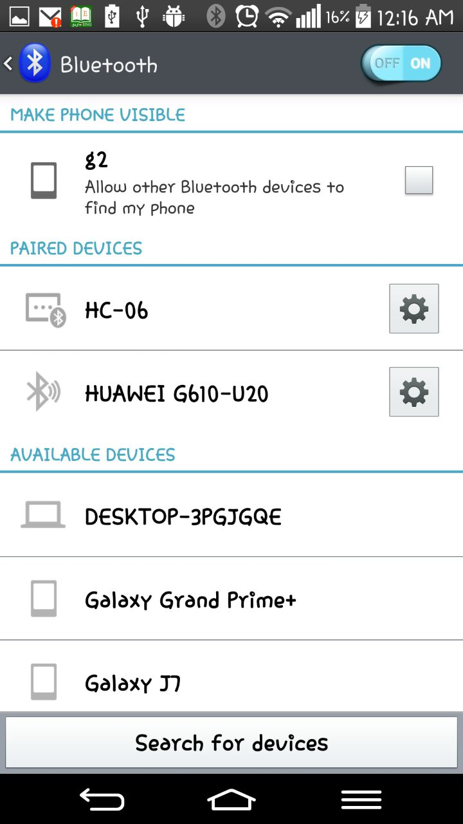

Figure 31 Pairing the mobile with HC-06

## 5.1.2 Startup the Application and connected the HC-06

After the step of pairing the Bluetooth module with the mobile phone then we launched the disaster Detection Application where were paired Bluetooth devices. Then connected the paired HC-06 module.



Figure 32 Bluetooth Page

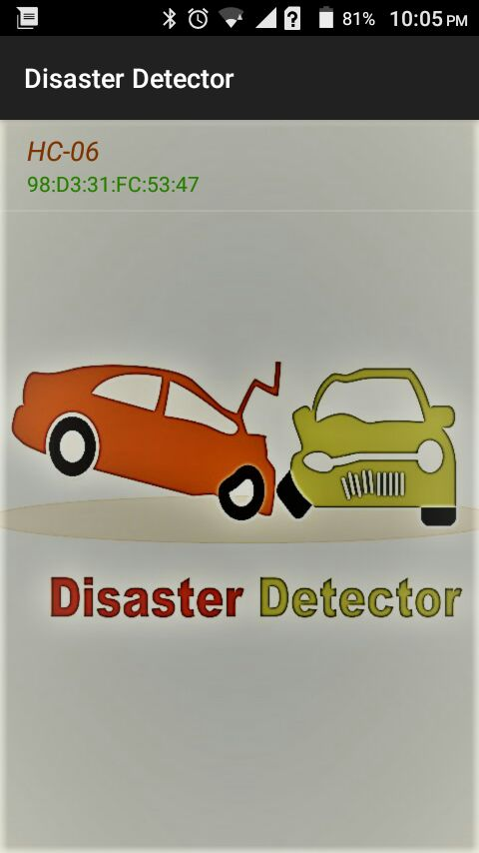

Figure 33 Application Loading

## 5.1.3 Entered the Required Data

When the Bluetooth module paired and connected with the mobile phone the next page started. In those page two types of data is required by the driver of the vehicle. First one was the name of that driver and second was the contact number whom the alert message will be transmitting in case of emergency. Same on that page we had the current values of the latitude and longitude of the vehicle in form of degree.

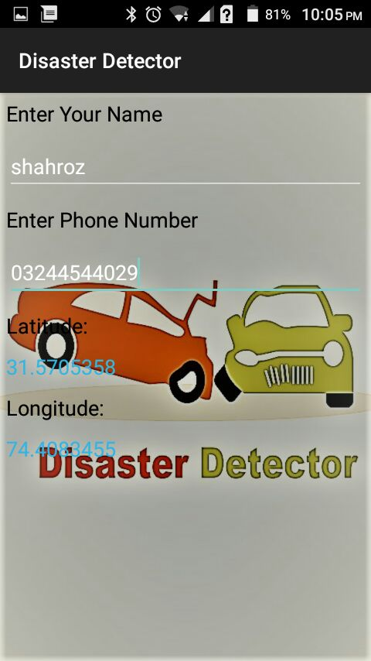

Figure 34 Main Page

# 5.2 Result

While moving the vehicle an accident occurred and the vibration sensor sent the signal to the Arduino for alerting the loved one. As soon as Arduino got a signal from the vibration sensor within two seconds Arduino transmitted a message to the mobile application through Bluetooth module. The application sent the alert message in form SMS to the concerned person with location of the spot.

The concerned person received a message having emergency note as well as accident location. So the man checked the location and called the emergency services after verifying the whole situation from the driver.

Figure 35 Alert SMS

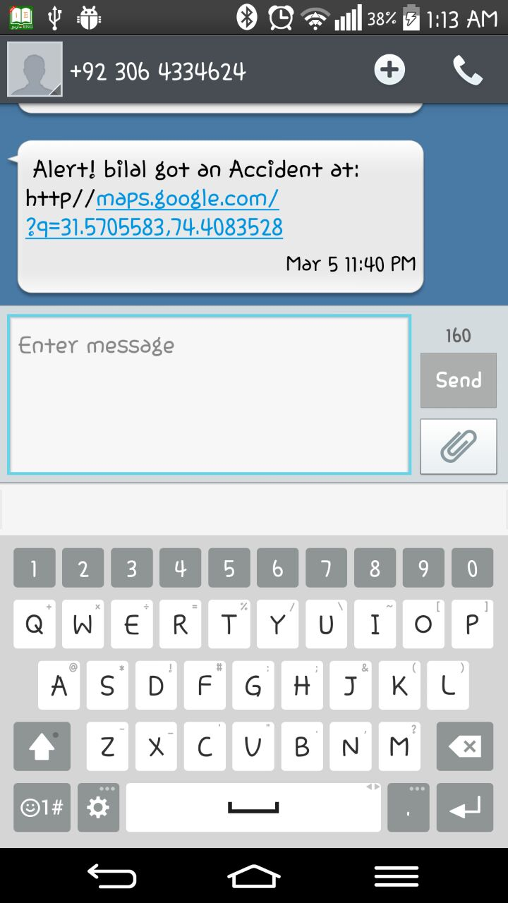

Figure Google Map location of the spot

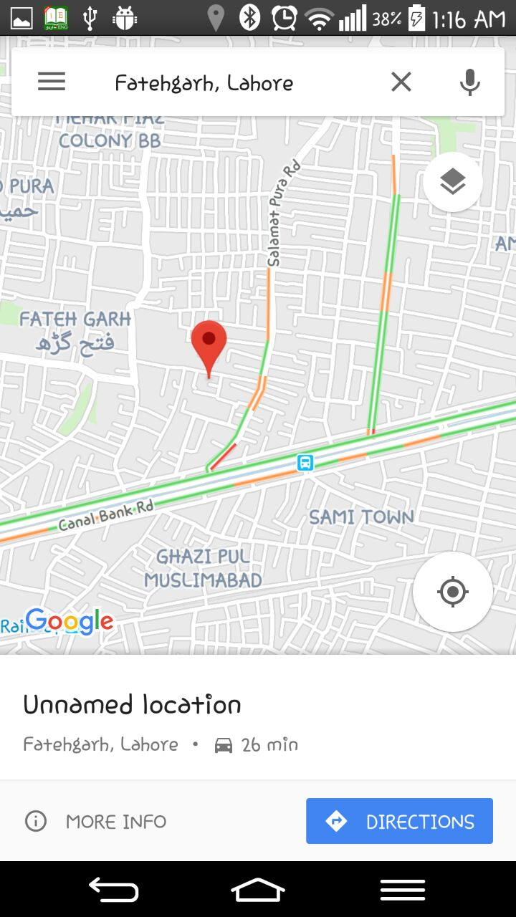

# Chapter 6

Conclusion and Future Direction

At the end of the every project we have to give the conclusion and the future aspects of the working. The main reason behind the conclusion is to give our reader a very simple and short term idea so may he can understand our whole working with very clear and unambiguous thoughts. In this regard not only the conclusion is necessary but the plans for the future are also need to mention.

# 6.1 Conclusion

In this era of science and technology world have undergone with huge progress in almost every field of life. If we talk about the revolution in the transportation industry then we can see that we are far away from the last few decades. But we also notice the major issues due to this modern development. The very major issues are the accidents occurring number of times in a day in whole world. We have also noticed that the death casualties are not just because of the accidents, but reason is that accidents are not identified and located due to various reasons. A large number of people die just because after an accident they are invisible to be identified and due to no rescue backup.

So we developed Disaster detection system to fill the gap of backup after an accident occurred. The Arial view of our system is that we have a hardware unit fitted in the vehicle and an android mobile application installed in the driver’s smart phone. As soon as the vehicle got a crash the hardware unit will send the signal to the mobile application through which the concerned person will be send a SMS including the pin point location of the spot.

Our system is consisted of the two parts know as hardware and software parts. The hardware part includes a printed circuit board for the connections among the different electronic components.

The main part is the Arduino (The main brain of system) which is for the communication between the software and hardware modules. There are two kinds of sensors used vibration and accelerometer MPU 6050. For the sack of the communication between the android application and the Arduino we used the Bluetooth module HC-06. For the purpose of the electric current we used two batteries each of 4V which is further converted into 5 voltages that is the actual required voltage for the smooth working of the circuit.

In the part of the software side we have developed an android application which is very simple to use and user friendly. In the front end of the application the user just need to enter his name and the mobile number of the concerned person whom the alert SMS will be transmitted. We used Microsoft visual studio for the development of the android application using the C# language through Xamrine platform.

In testing and use cases we have seen that our project gave very good performance and high level of accuracy. We tested our project in almost all the conditions and scenarios.

# 6.2 Future Direction

In every kind of system there must be some planning and brain work to entertain the needs and features for the future because we have to deal with various new updated scenarios which require modification and updated planning. Same case is with our project due to which we also have thoughts and ideas in minds to enhance the usability and durability of our system. Followings are the main thoughts as our future planning for the better performance.

## 6.2.1 Panic Button

We know very well that sometimes while we are driving the vehicle, there might be some conditions that we got an accident but of minor level. So definitely we will never intend to inform the family because it will make an extra ordinary worse environment for them. That’s why we have a plan to avoid this kind of situation in form a panic button. The idea is that as soon as we got accident there will be a panic button and if you do not want to inform your family then within 10 seconds, you have time to click that button floating on your mobile application screen.

## 6.2.1 Link with Local Emergency services

As in current case we have just feature to inform our relatives or loved ones but we need more attention of the nearest emergency services than our loved ones. We have a plan to develop a system through which we can send alert message to the rescue services with the location of collision. After the addition of this feature our system will be more attractive and more useful for the sack of human survival.

## 6.2.2 Entering of Multiple Alerted Contacts

Sometimes we need backup from our families after got an accident but due to the network problem our loved one could not get message which is very worst condition for anyone. So to eradicate this rare scenario we have a plan. We will provide more than one fields to enter the mobile numbers whom you want to inform in case of any emergency. There might be condition that first it will check weather the first person got SMS or not, if message received by first person then it’s good, but if not received by first person then the number entered in second preference will be send message.

## 6.2.3 Mobile Application for IOS Users

There are mostly two types of users in the world. One having Android smart phones and second Apples IPhone users. But in current case we have just developed the system for the Android users not for IPhone users. So in future direction we have a plan to develop the mobile application that all types of users could install and get advantages of it.

# Chapter 7

Planning of work

For the developing of any product we need a proper planning and scheme of work to avoid any kind of problem during the project working. If we have a proper plan for our work we will be doing in an easy and reliable way. We just not only work properly through planning but we know that what a task is given to me and it is my responsibility to tackle it. So we always take responsibility if we have proper and defined work.

# 7.1 Distribution of work

It a good gesture for every team to distribute the work among themselves in some certain ways so that everyone must knew what he do and what is his responsibility. On the basis of certain specialties, interests and past experiences we also have divided whole project among ourselves. It does not mean that if someone is doing a specific task and others don’t have knowledge about it. Actually when one is doing work as leader others are the supporting shoulders to him. Following is the tale of distribution of the work among us.

|  |  |  |  |
| --- | --- | --- | --- |
| **Task** | **Shahroz** | **Bilal** | **Ali** |
| **Requirements gathering** | ○ | ● | ○ |
| **Analyze Social Aspects** | ● | ○ | ○ |
| **Design the Block Diagram** | ○ | ○ | ● |
| **Design Flow chart** | ○ | ● | ○ |
| **Design code for Android App** | ● | ○ | ○ |
| **Design code for Arduino** | ○ | ○ | ● |
| **Build the User Interface for Android App** | ○ | ● | ○ |
| **Connect Bluetooth with App** | ● | ○ | ○ |
| **Write the Monthly Reports** | ○ | ○ | ● |
| **Test the User Interface** | ○ | ● | ○ |
| **Perform Integration Testing** | ○ | ○ | ● |
| **Write the Proposal** | ● | ○ | ○ |
| **Write the Progress Report** | ○ | ○ | ● |
| **Write the Final Report** | ○ | ○ | ● |
| **Prepare for the Presentation** | ● | ○ | ○ |
| **Design the Project Poster** | ● | ○ | ● |

Table 2 Work distribution

# 7.2 Gantt Chart

Gantt chart is used for planning of the work in all types of projects. Actually the Gantt chart is a best to way to show that what work is planned for a specific day during the development if whole project. In simple way we can check the overview of the starting and ending dates of a certain project.

|  |  |  |  |  |  |  |  |  |  |  |
| --- | --- | --- | --- | --- | --- | --- | --- | --- | --- | --- |
| Tasks | July | Aug | Sep | Oct | Nov | Dec | Jan | Feb | Mar | Apr |
| **Requirements gathering** |  |  |  |  |  |  |  |  |  |  |
| **Analyze Social Aspects** |  |  |  |  |  |  |  |  |  |  |
| **Design the Block Diagram** |  |  |  |  |  |  |  |  |  |  |
| **Design Flow chart** |  |  |  |  |  |  |  |  |  |  |
| **Design code for Android App** |  |  |  |  |  |  |  |  |  |  |
| **Design code for Arduino** |  |  |  |  |  |  |  |  |  |  |
| **Build the User Interface for Android App** |  |  |  |  |  |  |  |  |  |  |
| **Test the User Interface** |  |  |  |  |  |  |  |  |  |  |
| **Connect Bluetooth with App** |  |  |  |  |  |  |  |  |  |  |
| **Test the User Interface** |  |  |  |  |  |  |  |  |  |  |
| **Perform Integration Testing** |  |  |  |  |  |  |  |  |  |  |
| **Write the Proposal** |  |  |  |  |  |  |  |  |  |  |
| **Write the Progress Report** |  |  |  |  |  |  |  |  |  |  |
| **Write the Monthly Reports** |  |  |  |  |  |  |  |  |  |  |
| **Write the Final Report** |  |  |  |  |  |  |  |  |  |  |
| **Prepare for the Presentation** |  |  |  |  |  |  |  |  |  |  |

Table 3 Gantt chart

# References:

**[1] *Traffic Accidents (Annual 2015-2016)*. (2017). *Pbs.gov.pk*. Retrieved 8 February 2018, from http://www.pbs.gov.pk/content/traffic-accidents-annual**

**[2]Prachi, B., Kasturi, D., & Priyanka, C. (2014). Intelligent accident-detection and ambulance-rescue system. *PULSE*, *450*(16), 2.**

**[3] *FAQ*. *SOSmart automatic car crash detection app*. Retrieved 9 February 2018, from http://www.sosmartapp.com/faq.html**

**[4] Kaladevi, P., Kokila, T., Narmatha, S., & Janani, V. (2014). Accident Detection Using Android Smart Phone. *Int. J. Innov. Res. Comput. Commun. Eng*, *2*, 2367-2372.**

**[5] V. Anupriya, B. Lissy Roy, V. Dheepthi, & Farhat Masood. (2015). Smart Accident Notification and Collision Avoidance System. *International Journal Of Engineering Research And*, *V4*(04). http://dx.doi.org/10.17577/ijertv4is040964**

**[6] Sane, N. H., Patil, D. S., Thakare, S. D., & Rokade, A. V. Real Time Vehicle Accident Detection and Tracking Using GPS and GSM. *International Journal on Recent and Innovation Trends in Computing and Communication ISSN*, 2321-8169.**

**[7] Jeon, J., Micinski, K. K., Vaughan, J. A., Fogel, A., Reddy, N., Foster, J. S., & Millstein, T. (2012, October). Dr. Android and Mr. Hide: fine-grained permissions in android applications. In *Proceedings of the second ACM workshop on Security and privacy in smartphones and mobile devices* (pp. 3-14). ACM.**

**[8] Xiong, H., Huang, Y., Barnes, L. E., & Gerber, M. S. (2016, September). Sensus: a cross-platform, general-purpose system for mobile crowdsensing in human-subject studies. In *Proceedings of the 2016 ACM International Joint Conference on Pervasive and Ubiquitous Computing* (pp. 415-426). ACM.**

**[9] *Arduino Programming language*. (2018). *Arduino.cc*. Retrieved 17 February 2018, from https://www.arduino.cc/en/Main/FAQ**

# Plagiarism Report

